Research note: Use of the NHS COVID-19 App
Prof. Henry Potts
2 Nov 2020
Exec. summary
- The sample used in DHSC polling shows higher smartphone usage and NHS COVID-19 app usage than the general population.
- Predictors of having the app (in the whole population) are being in work; not being a sole carer for dependent children; and worrying about coronavirus
- Predictors of having the app (in those with smartphones) are not being a sole carer for dependent children; and worrying about coronavirus

Introduction
This note covers use of the NHS COVID-19 App, focusing on predictors of whether has the app. While uptake has been high (approx. 18 million to date), penetrance remains below what is needed for a contact tracing app to be fully effective. To increase uptake, it is useful to know why people may not have the app.
DHSC polling data collected 12-14 October 2020 (n = 2072) was analysed.

Descriptive analyses
Do you have a smartphone?
Yes, and I usually take it out with me: 81%
Yes, but I do not usually take it out with me: 8%
No: 10%
Don’t know: 1%
OFCOM (2019) reported 79% of adults have a smartphone. In comparison, 89% (81% yes and take it with them + 8% yes and do not take it with them) of respondents report having a smartphone.

Have you downloaded the NHS COVID-19 app? (of those with a smartphone)
Yes, I downloaded it and I have it on my phone: 51%
Yes, I previously downloaded it but since deleted it: 2%
I tried to download it but couldn’t: 7%
No, I have not tried to download it: 37%
Don't know: 3%
The UK adult population is around 52 million. If 79% have a smartphone (OFCOM, 2019), that means there are 41 million adults with a smartphone. The app has had 18 million downloads, so that means about 44% of adults with a smartphone have downloaded the app. In comparison, 53% (51% downloaded and have + 2% downloaded but since deleted) of respondents have downloaded the app.
It is perhaps not surprising that members of an Internet panel would be greater adopters of such technologies.

Which functions have people used?
Viewed my area’s risk level 76%
Checked in at a venue using a QR code 51%
Checked if I have coronavirus symptoms 27%
Booked a coronavirus test 7%
Kept track of my self-isolation countdown 12%
Had “contact tracing” mode switched on when out and about 72%
Was alerted that I had come into close contact with someone who tested positive for coronavirus 8%

Note the figure of 72% for having “contact tracing” mode switched on. If people have this mode switched off, that reduces the effective penetrance of the app.

For those who have downloaded the app, proportion saying strongly agree or agree:
The app will allow me to actively protect my loved ones 69%
The app is the fastest way to know when I am at risk of Coronavirus 67%
The app helps limit the spread of coronavirus 63%
The app is easy to use 81%
The app has useful functions 70%
I have concerns about privacy and the use of my data in the app 37%

A factor analysis found the first 5 items to group together, while the final item constituted a separate factor.

How likely are you to recommend the app to family and friends? From 0 not at all likely to 10 extremely likely:
4% say 0
median rating of 8
34% say 10

Who has the app?
We conducted a series of analyses looking at possible predictors of having the app. Individuals were classified as having the app if they have a smartphone and answered “Yes, I downloaded it and I have it on my phone” to the question “Have you downloaded the NHS COVID-19 app?” Thus, people without a smartphone and people with a smartphone but not using the app are combined.
We started with univariable analyses comparing individual variables with having the app. The following variables did not show a significant relationship with having the app.
Region: no difference (χ²(11) = 13.8, p = 0.2)
Gender: no difference (exact p = 0.2)
English as first language: no difference (exact p = 0.1)
Live alone: no difference (exact p = 0.055)
Have a long-standing illness? No difference (exact p = 0.8)
Another member of household has a long-standing illness? No difference (exact p = 0.4)
Religion: no difference (exact p = 0.067)
Hardship (3 = least hardship to 15 = most hardship): not significant (Mann-Whitney p = 0.1)

The following variables did show a significant relationship with having the app:

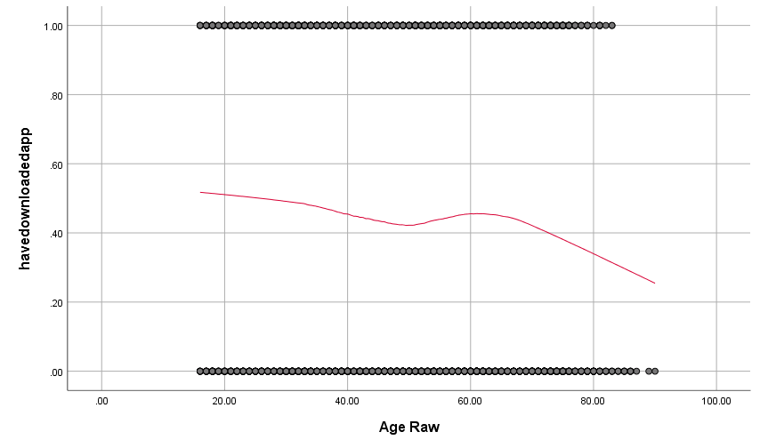
Figure 1: Loess plot of having the app against age.

Age: significant negative correlation with having the app: see Fig. 1.
Ethnicity: significant difference (exact p = 0.006). Percentage having the app:
White British 47% Asian/Asian British 41%
Mixed 40% White Other 37%
Black/Black British 20%
Marital status: significant difference (exact p = 0.002) Percentage having the app:
Married/partnered 49% Not 42%
Are you the sole carer for the dependent children in your household? Significant difference. Percentage having the app:
Yes 43% No 55%
Work for the NHS? Significant (exact p = 0.016). Percentage having the app:
Yes 55% No 45%
Education level: significant difference, e.g. with Master’s 51% vs. no qualification 31%
In work: significant difference (exact p = 0.001). Percentage having the app:
In work 49% Not 42%
Perceived credibility of government (4 = lowest credibility to 20 = highest credibility): higher perceived credibility associated with having the app (Mann-Whitney p = 0.001)
Worry about COVID-19 (1=not at all worried to 5=extremely worried): higher worry associated with having the app (Mann-Whitney p < 0.001)

A multivariable logistic regression was constructed to predict having the app. The only significant predictors were:
Being a sole carer for dependent children: OR = 0.54 (95% CI 0.38-0.76)
Being in work: OR = 1.49 (95% CI 1.02-2.17)
Worry about coronavirus (5-point scale): OR per point = 1.36 (95% CI 1.17-1.59)

Who has the app (smartphone owners only)?
We repeated analyses but only for individuals who have a smartphone: only the multivariable analysis is shown. Individuals were classified as having the app if they have a smartphone and answered “Yes, I downloaded it and I have it on my phone” to the question “Have you downloaded the NHS COVID-19 app?” People without a smartphone were excluded.
A multivariable logistic regression was constructed to predict having the app. The significant predictors were:
Being a sole carer for dependent children: OR = 0.52 (95% CI 0.36-0.75)
Worry about coronavirus (5-point scale): OR per point = 1.36 (95% CI 1.15-1.60)

Conclusion
Worry about the virus is a key driver for having the app.
Being a sole carer for dependent children is a strong predictor of not having the app, controlling for hardship, being in work and other variables: qualitative research is recommended to explore what might be happening with this group.
Being in work is a predictor for having the app across the whole population, although it fails to reach significance when considering just those who have a smartphone.
Other variables are not significant predictors once controlling for the above.

References
OFCOM (2019). Communications Market Report 2019. OFCOM. https://www.ofcom.org.uk/__data/assets/pdf_file/0028/155278/communications-market-report-2019.pdf [data accessed: 2 Nov 2020]

Please note that this work has been conducted rapidly and has not been peer reviewed or subject to normal quality control measures.

Professor Henry W.W. Potts (UCL), Dr Louise E. Smith (KCL), Professor Nicola T. Fear (KCL), Professor Susan Michie (UCL), Professor Richard Amlȏt (PHE), Dr G James Rubin (KCL)

Contact details: h.potts@ucl.ac.uk, louise.e.smith@kcl.ac.uk, richard.amlot@phe.gov.uk, gideon.rubin@kcl.ac.uk

