Changes in behaviour following 19 July 2021
6 August 2021

On 19 July 2021, all remaining legal limits on social contacts were removed.
Aim: to investigate whether behaviours differed after the removal of restrictions.
Findings:
- Social mixing: Engagement in highest risk social mixing continues to increase (Figure 1), but at a steady rate: 19 July did not result in a step change.
- Intention to self-isolate if you were to develop COVID-19 symptoms: Intention fell dramatically in line with Step 3 of the roadmap out of lockdown (17 May 2021; indoor socialising [rule of six or two households] introduced, foreign travel permitted; Figure 2). When comparing the latest two waves of data collection (before and after 19 July 2021), intention to self-isolate increased.
- Intention to request a test if you were to develop COVID-19 symptoms: There was no evidence for a change in intention after 19 July 2021 (Figure 2).
- Uptake of lateral flow testing (LFT): Uptake shows a slight increase since becoming available to all adults (April 2021; Figure 3). There was no evidence for a change in uptake after 19 July 2021.
- Wearing a face covering: The percentage of people wearing a face covering in all settings (shops, meeting friends/family from other households, hospitality, public transport) fell (Table 1).
- Deleting the COVID-19 app: When comparing the latest two waves of data collection (before and after 19 July 2021), the number of people who reporting previously having had the COVID-19 app but having since deleted it increased (Table 2).

Main report

Risky social mixing
Figure 1. Patterns of risky social mixing over time (England only; see Appendix 1 for classification of risk).
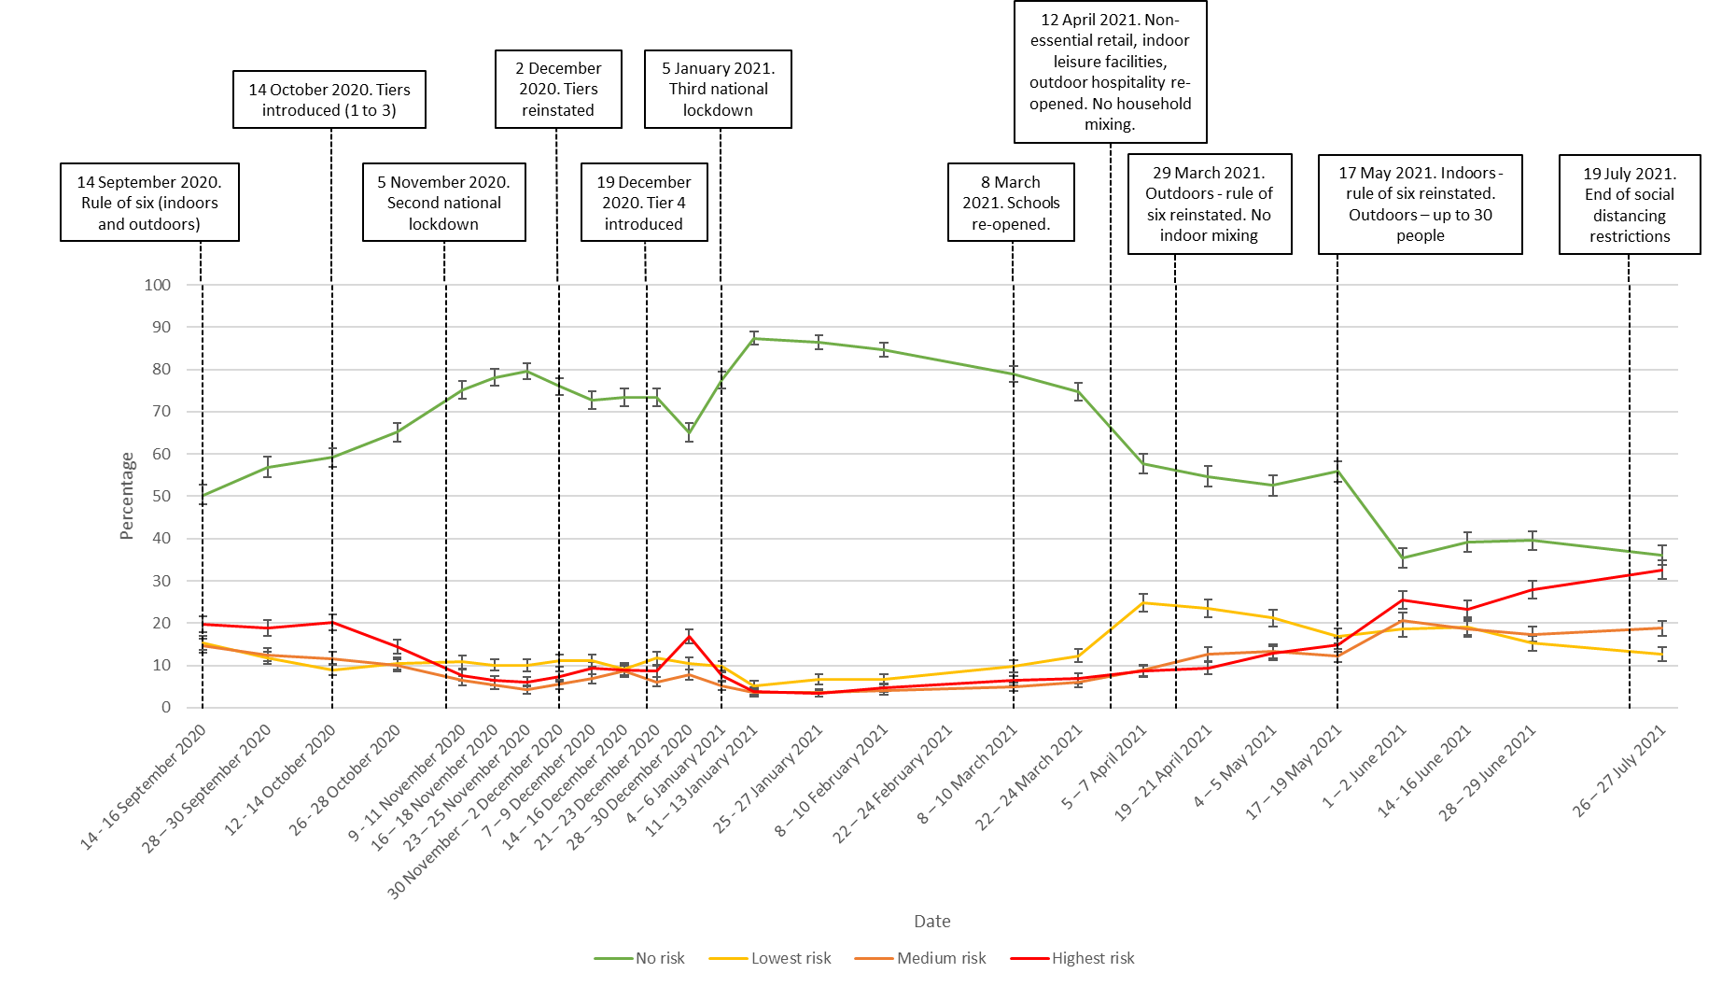

Test, trace and isolate
Figure 2. Percentage of people who intend to self-isolate and request a test if they develop COVID-19 symptoms (UK population).
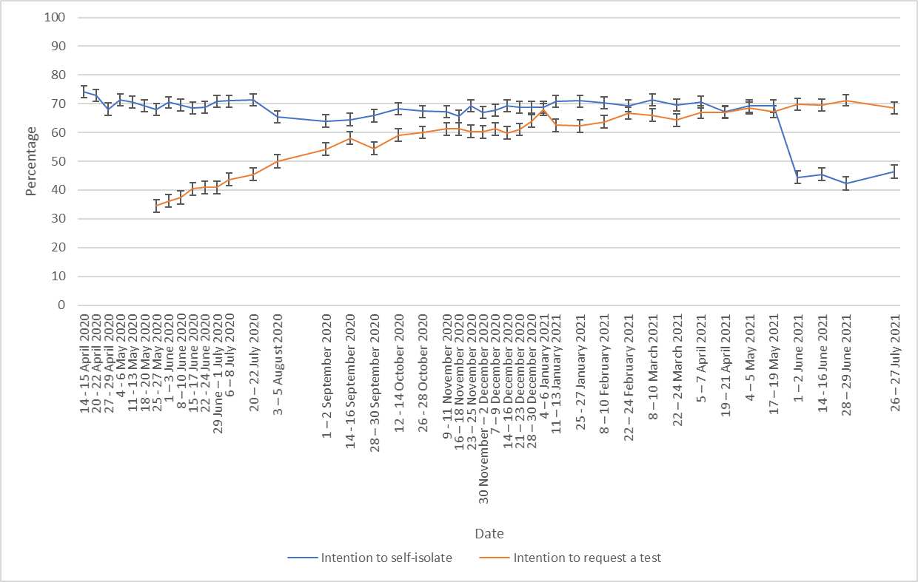
We ran$χ$² tests to compare the last two waves of data collection:
- Intention to self-isolate if you were to develop COVID-19 symptoms increased ($χ$²(1)=6.8, p=.009).
- There was no evidence for a change in intention to request a test if you were to develop COVID-19 ($χ$²(1)=3.2, p=.08).

Uptake of lateral flow testing (LFT)
Figure 3. Uptake of LFT testing (England and Scotland adults only, completed a test in the last week, excluding people whose latest test was a PCR test).

We ran$χ$² tests to compare the last two waves of data collection. There was no evidence for a change in uptake in lateral flow testing ($χ$²(1)=0.2, p=.63).

Wearing a face covering
Table 1. Percentage of people who reported wearing a face covering while engaging in different out-of-home activities (UK population)
 | “While you were doing each of these activities in the past seven days, did you wear a face covering?”
 |  | 17 – 19 May 2021, % (n) | 1 – 2 June 2021, % (n) | 28 – 30 June 2021, % (n) | 26 – 27 July 2021, % (n)
In shops, for groceries/pharmacy | Yes - on all occasions | 75 (1275) | 73 (1265) | 74 (1293) | 65 (1111)
 | Yes - on some occasions | 17 (282) | 18 (311) | 17 (300) | 22 (369)
 | No - not at all | 9 (145) | 10 (165) | 9 (162) | 14 (234)
 | Total n | 1702 | 1741 | 1755 | 1714
When meeting up with friends and/or family that you don't live with | Yes - on all occasions | 30 (267) | 26 (343) | 30 (370) | 24 (309)
 | Yes - on some occasions | 34 (308) | 36 (463) | 33 (413) | 33 (415)
 | No - not at all | 37 (330) | 38 (498) | 37 (453) | 43 (553)
 | Total n | 905 | 1304 | 1236 | 1277
In a restaurant, café, or pub | Yes - on all occasions | 49 (258) | 57 (511) | 55 (487) | 44 (410)
 | Yes - on some occasions | 36 (189) | 30 (266) | 34 (299) | 34 (324)
 | No - not at all | 15 (78) | 13 (113) | 11 (93) | 22 (209)
 | Total n | 525 | 890 | 879 | 943
On public transport or in a taxi/minicab | Yes - on all occasions |  | 67 (417) | 68 (408) | 64 (410)
 | Yes - on some occasions |  | 23 (144) | 20 (122) | 24 (153)
 | No - not at all |  | 10 (59) | 12 (72) | 12 (77)
 | Total n |  | 620 | 602 | 640

The percentage of people wearing a face covering decreased after 19 July. Compared to the previous survey wave, wearing a face covering decreased by:
- 9 percentage points in shops.
- 6 percentage points when meeting friends or family from another household.
- 11 percentage points in hospitality settings.
- 4 percentage points on public transport.

Contact tracing app
Table 2. Percentage of people who reported having the NHS COVID-19 app downloaded on their phone (UK population, only people who reported having a smartphone)
 | “Do you have the NHS COVID-19 APP downloaded on your phone?”
 | 17 – 19 May 2021, % (n) | 14 – 15 June 2021, % (n) | 26 – 27 July 2021, % (n)
Yes, I downloaded it and I have it on my phone | 50 (762) | 50 (775) | 49 (789)
I previously downloaded it but since deleted it | 11 (164) | 8 (122) | 13 (204)
I tried to download it but couldn't | 6 (96) | 8 (120) | 6 (99)
No, I have not tried to download it | 32 (492) | 33 (515) | 31 (496)
Don’t know | 2 (26) | 1 (18) | 1 (10)
Total n | 1540 | 1550 | 1598

We ran$χ$² tests to compare the last two waves of data collection. There was a significant change (χ²(4)=24.7, p<0.001), with more people reporting having previously downloaded the app but since deleting it. However, the actual increase in people deleting the app is relatively small. The Good Morning Britain/Survation poll found a bigger increase (albeit using a smaller sample size).

Datasets used:
- Department of Health and Social Care weekly tracker
  - Tracking DHSC marketing, coronavirus attitudes, beliefs, knowledge, reported behaviour, satisfaction with Government response, credibility of Government.
  - Data collected weekly (Monday to Wednesday) since late January.
  - N~2000 per wave.
  - Market research company commissioned: BMG Research.
Please note that this work has been conducted rapidly and has not been peer reviewed or subject to normal quality control measures.

Dr Louise E. Smith (KCL), Professor Nicola T. Fear (KCL), Professor Henry W.W. Potts (UCL), Professor Susan Michie (UCL), Professor Richard Amlȏt (PHE), Dr G James Rubin (KCL)

Contact details: louise.e.smith@kcl.ac.uk, h.potts@ucl.ac.uk, richard.amlot@phe.gov.uk, gideon.rubin@kcl.ac.uk

Appendix 1. Classification of risky social mixing

Number of meetings in last week | 0 | 1+
Setting |  | Exclusively outdoors |  |  |  |  |  |  |  | Mostly outdoors |  |  |  |  |  |  |  | Indoors
Close contact |  | Distanced |  |  |  | Not distanced |  |  |  | Distanced |  |  |  | Not distanced |  |  |  | Distanced |  |  |  | Not distanced
Total number of households |  | 2 |  | 3+ |  | 2 |  | 3+ |  | 2 |  | 3+ |  | 2 |  | 3+ |  | 2 |  | 3+ |  | 2 |  | 3+
Number of people from other households |  | ≤2 | ≥3 | ≤2 | ≥3 | ≤2 | ≥3 | ≤2 | ≥3 | ≤2 | ≥3 | ≤2 | ≥3 | ≤2 | ≥3 | ≤2 | ≥3 | ≤2 | ≥3 | ≤2 | ≥3 | ≤2 | ≥3 | ≤2 | ≥3
RISK | No | Low | Low | Low | Low | Low | Low | Med | Med | Low | Med | Med | Med | Med | Med | High | High | Med | High | High | High | High | High | High | High

Details available on request.

