Agency and risk - impact on adopting protective behaviours
Louise Smith, Henry Potts, CORSAIR team, 5 November 2021

Executive summary
- Perceptions of risk and levels of worry have varied across the pandemic, broadly in line with the introduction and release of restrictions (Figure 1). Worry and perceived risk has remained stable since Step 3 of the roadmap (indoor social mixing, 17 May 2021).
  - Efforts should be made to ensure the risk of infection is well understood by the population.
- Greater perceived worry about COVID-19 was associated with uptake of protective behaviours (less likely to engage in risky social mixing, more likely to wear a face covering and cleanse hands) as was greater perceived risk of COVID-19 to people in the UK (more likely to wear a face covering and cleanse hands; Table 1).
  - We are unable to tell whether individuals are making informed risk-based decisions as it depends on individual circumstances which are unknown to us.
- Locus of control was not associated with adoption of protective behaviours, except for wearing a face covering (Table 1).
  - Internal locus of control was associated with being more likely to wear a face covering. Chance locus of control was associated with being less likely to wear a face covering.
    - In practice, there was a greater difference in wearing a face covering by internal locus of control (Figure 2). There was a small difference in wearing a face covering by chance locus of control (Figure 3).
  - Viewing those who catch COVID as being irresponsible, a form of social condemnation, was associated with less risky social mixing and more mask wearing.
- Some socio-demographic characteristics were associated with adoption of protective behaviours (Table 1).
  - Older participants were less likely to engage in risky social mixing, less likely to have taken an LFT and more likely to engage in hand cleansing in the last week.
  - People who were employed were less likely to engage in risky social mixing and more likely to have taken an LFT in the last week.

Worry and risk perceptions over time
Worry and perceived risk of COVID-19 has broadly followed UK case numbers / restrictions in place at the time (Figure 1).

Figure 1. Graph depicting worry and perceived risk (to self and others in the UK) over the pandemic
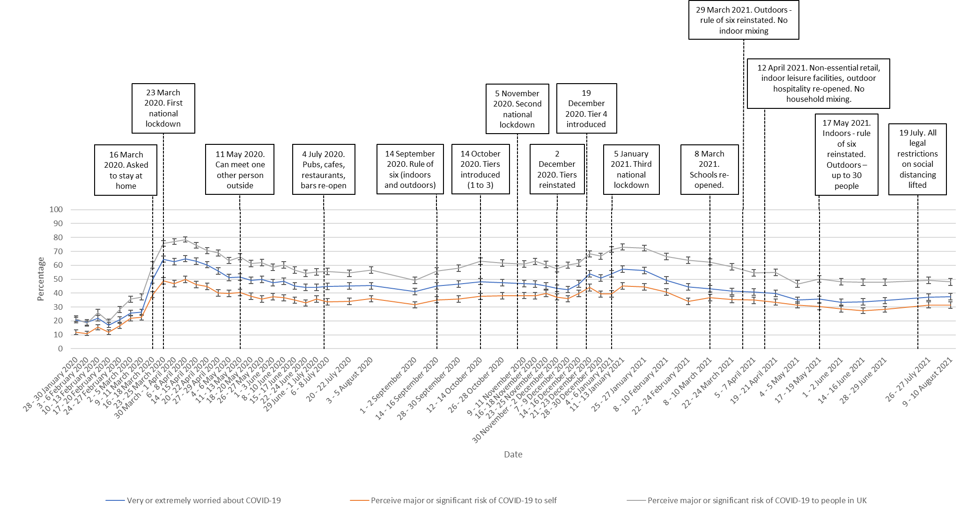

How effective do people think protective behaviours are?
Generally, people think protective behaviours are effective at preventing the spread of COVID-19 (Table 1):
- 88% agree or strongly agree – hand cleansing
- 84% agree or strongly agree – keeping the number of people you meet to a minimum
- 80% agree or strongly agree – socialising outdoors rather than indoors
- 79% agree or strongly agree – wearing a face covering
- 71% agree or strongly agree – asymptomatic testing

Table 1. Perceived effectiveness of different behaviours (wave 55 only)
An effective way to prevent the spread of coronavirus is to… [total n=1706] | Strongly agree, % (n) | Agree, % (n) | Neither agree nor disagree, % (n) | Disagree, % (n) | Strongly disagree, % (n) | Don’t know, % (n)
…Keep the number of people you meet to a minimum | 36.0 (615) | 47.9 (817) | 11.1 (189) | 2.9 (50) | 1.2 (21) | 0.8 (14)
…Socialise outdoors rather than indoors | 30.5 (521) | 49.9 (852) | 11.8 (202) | 4.4 (75) | 1.8 (31) | 1.5 (25)
Regularly testing people without symptoms is an effective way to prevent the spread of coronavirus | 21.4 (365) | 49.2 (839) | 18.8 (321) | 5.1 (87) | 2.5 (43) | 3.0 (51)
…Wear a face mask or another face covering (such as a scarf) when out and about | 39.6 (676) | 39.7 (677) | 12.2 (208) | 4.6 (78) | 3.2 (54) | 0.8 (13)
…Wash your hands thoroughly and regularly with soap and water, or use hand sanitising gel | 47.4 (809) | 40.9 (697) | 8.1 (138) | 2.0 (34) | 1.1 (18) | 0.6 (10)

Locus of control and other agency questions
A number of new questions around health locus of control and other attitudinal items were recently added to the survey. Analyses are of waves 54 and 55, England only. We investigate here whether they are associated with behaviours, namely:
- Risky social mixing
- Having taken a LFT in the last week (excluding people whose most recent test was a PCR test and those who took a PCR test when symptomatic)
- Mask wearing (all or some of the time) in a shop (analyses restricted only to people who reported going out shopping in the last week)
- Hand washing (on returning home)
Results of statistical analyses are reported in Table 2.
Worry was associated with less risky social mixing, more mask wearing and more handwashing. A higher perceived risk to oneself was, counter-intuitively, associated with less handwashing. Higher perceived risk to people in the UK was associated with more mask wearing and handwashing. Perceived risk to friends and family was not independently associated with the outcomes considered.
Internal locus of control was associated with more mask wearing, and chance locus of control was associated with less mask wearing. Powerful others (government) locus of control was not statistically significantly associated. Viewing those who catch COVID as being irresponsible, a form of social condemnation, was associated with less risky social mixing and more mask wearing.
Susceptibility was associated with having taken an LFT in the last week, while severity judgements were associated with less risky social mixing and more mask wearing.
Perceived effectiveness was strongly associated with risky social mixing, having taken a LFT in the last week, mask wearing and handwashing. However, the only self-efficacy item that was associated was for handwashing.

Table 2. Factors associated with risky social mixing, having taken a LFT, wearing a face covering in a shop, and hand washing, in the last week. Bolding denotes significant finding (p<.05).
 |  | Risky social mixing |  | Having taken a LFT in the last week |  | Wearing a face covering in a shop |  | Hand washing – only measured in W55
Factor | Level | Adjusted odds ratio (95% CI) for engaging in highest risk social mixing † | p-value | Adjusted odds ratio (95% CI) for having completed a test † | p-value | Adjusted odds ratio (95% CI) for having worn a face covering † | p-value | Adjusted odds ratio (95% CI) for having washed hands ‡ | p-value
Survey wave | 26 - 27 July 2021 (wave 54) | Ref | - | Ref | - | Ref | - | - | -
 | 9 - 10 August 2021 (wave 55) | 1.12 (0.95 to 1.31) | .17 | 0.96 (0.79 to 1.16) | .65 | 0.86 (0.68 to 1.09) | .22 | - | -
Region | East Midlands | Ref | - | Ref | - | Ref | - | Ref | -
 | East of England | 1.28 (0.90 to 1.84) | .17 | 1.10 (0.72 to 1.67) | .65 | 0.87 (0.51 to 1.47) | .60 | 0.63 (0.31 to 1.27) | .20
 | London | 1.21 (0.85 to 1.73) | .30 | 1.01 (0.67 to 1.53) | .96 | 1.37 (0.78 to 2.41) | .27 | 0.90 (0.44 to 1.83) | .77
 | North East | 1.18 (0.76 to 1.84) | .45 | 0.93 (0.56 to 1.54) | .77 | 0.92 (0.47 to 1.76) | .79 | 1.18 (0.45 to 3.12) | .74
 | North West | 0.92 (0.65 to 1.30) | .64 | 0.91 (0.61 to 1.36) | .65 | 0.93 (0.55 to 1.55) | .77 | 0.95 (0.48 to 1.91) | .89
 | South East | 1.19 (0.85 to 1.68) | .30 | 1.09 (0.74 to 1.61) | .67 | 0.95 (0.57 to 1.58) | .85 | 0.67 (0.34 to 1.31) | .24
 | South West | 0.99 (0.69 to 1.42) | .96 | 0.97 (0.64 to 1.48) | .89 | 0.92 (0.54 to 1.58) | .77 | 0.62 (0.31 to 1.26) | .19
 | West Midlands | 1.03 (0.71 to 1.48) | .89 | 0.71 (0.46 to 1.10) | .12 | 0.81 (0.48 to 1.39) | .45 | 0.92 (0.44 to 1.92) | .83
 | Yorkshire and the Humber | 1.16 (0.81 to 1.67) | .42 | 0.95 (0.62 to 1.45) | .81 | 0.86 (0.50 to 1.47) | .57 | 0.60 (0.30 to 1.21) | .15
 | Overall | χ²(8)=7.3 | .50 | χ²(8)=5.8 | .67 | χ²(8)=4.9 | .77 | χ²(8)=7.6 | .47
Gender | Male | Ref | - | Ref | - | Ref | - | Ref | -
 | Female | 1.14 (0.97 to 1.34) | .12 | 1.08 (0.89 to 1.31) | .44 | 1.01 (0.79 to 1.29) | .94 | 1.29 (0.95 to 1.74) | .10
Age | Raw age | 0.91 (0.85 to 0.98) | .01 | 0.86 (0.79 to 0.94) | .001 | 0.95 (0.85 to 1.07) | .42 | 1.15 (1.01 to 1.31) | .04
Age: quadratic (age-mean)² | - | 1.0002 (0.9999 to 1.0004) | .32 | 1.0004 (1.0001 to 1.0008) | .02 | 1.0006 (1.0001 to 1.0011) | .01 | 1.0001 (0.9995 to 1.0006) | .75
Dependent child in household | None | Ref | - | Ref | - | Ref | - | Ref | -
 | Child present | 0.93 (0.76 to 1.14) | .48 | 0.79 (0.62 to 0.99) | .04 | 0.83 (0.61 to 1.12) | .22 | 0.93 (0.64 to 1.35) | .69
Clinically vulnerable to COVID-19 | None | Ref | - | Ref | - | Ref | - | Ref | -
 | Present | 0.94 (0.76 to 1.18) | .61 | 1.12 (0.86 to 1.46) | .41 | 0.92 (0.65 to 1.30) | .64 | 0.96 (0.64 to 1.46) | .86
Household member has chronic illness | None | Ref | - | Ref | - | Ref | - | Ref | -
 | Present | 0.89 (0.71 to 1.13) | .34 | 1.14 (0.87 to 1.49) | .33 | 1.00 (0.70 to 1.43) | 1.00 | 0.88 (0.57 to 1.35) | .56
Employment status | Not working | Ref | - | Ref | - | Ref | - | Ref | -
 | Working | 0.76 (0.63 to 0.93) | .01 | 1.81 (1.42 to 2.30) | <.001 | 1.20 (0.90 to 1.61) | .21 | 1.04 (0.72 to 1.51) | .83
Socio-economic grade | ABC1 | Ref | - | Ref | - | Ref | - | Ref | -
 | C2DE | 1.05 (0.87 to 1.27) | .62 | 1.12 (0.89 to 1.39) | .33 | 1.07 (0.81 to 1.41) | .63 | 0.93 (0.66 to 1.30) | .66
Index of multiple deprivation | 1st quartile (least deprived) to 4th quartile (most deprived) | 0.94 (0.87 to 1.01) | .09 | 1.00 (0.91 to 1.10) | 1.00 | 1.02 (0.91 to 1.14) | .78 | 0.91 (0.79 to 1.06) | .23
Highest educational or professional qualification | GCSE/vocational/A-level/No formal qualifications | Ref | - | Ref | - | Ref | - | Ref | -
 | Degree or higher (Bachelors, Masters, PhD) | 0.89 (0.74 to 1.07) | .21 | 1.17 (0.95 to 1.44) | .15 | 1.13 (0.86 to 1.49) | .38 | 0.90 (0.65 to 1.26) | .55
Ethnicity | White British | Ref | - | Ref | - | Ref | - | Ref | -
 | White other | 1.30 (0.85 to 2.00) | .23 | 1.15 (0.70 to 1.88) | .59 | 0.78 (0.42 to 1.44) | .43 | 1.31 (0.56 to 3.02) | .53
 | Black and minority ethnicity | 1.00 (0.73 to 1.38) | .99 | 0.97 (0.67 to 1.39) | .86 | 0.71 (0.46 to 1.12) | .14 | 1.36 (0.80 to 2.33) | .26
 | Overall | χ²(2)=1.5 | .48 | χ²(2)=0.4 | .83 | χ²(2)=2.4 | .30 | χ²(2)=1.5 | .48
Living alone | Not living alone | Ref | - | Ref | - | Ref | - | Ref | -
 | Living alone | 1.18 (0.95 to 1.45) | .13 | 0.87 (0.67 to 1.13) | .31 | 0.87 (0.63 to 1.19) | .38 | 0.83 (0.57 to 1.22) | .34
English as first language | No | Ref | - | Ref | - | Ref | - | Ref | -
 | Yes | 1.99 (1.29 to 3.07) | .002 | 1.25 (0.77 to 2.03) | .37 | 0.63 (0.33 to 1.18) | .15 | 0.63 (0.29 to 1.37) | .24
Had COVID-19 before | Think not | Ref | - | Ref | - | Ref | - | Ref | -
 | Think yes | 0.92 (0.74 to 1.14) | .44 | 1.13 (0.88 to 1.44) | .34 | 1.19 (0.87 to 1.63) | .27 | 0.79 (0.54 to 1.15) | .22
Vaccination status | Not vaccinated | Ref | - | Ref | - | Ref | - | Ref | -
 | 1 dose | 0.83 (0.59 to 1.15) | .26 | 1.83 (1.23 to 2.71) | .003 | 1.04 (0.66 to 1.64) | .86 | 1.22 (0.66 to 2.25) | .52
 | 2 doses | 1.15 (0.88 to 1.49) | .30 | 2.08 (1.48 to 2.93) | <.001 | 1.74 (1.21 to 2.50) | .003 | 0.88 (0.56 to 1.41) | .60
 | Overall | χ²(2)=4.5 | .11 | χ²(2)=18.1 | <.001 | χ²(2)=10.7 | .005 | χ²(2)=1.3 | .53
Financial hardship | Range 3 (least) to 15 (most) | 0.96 (0.93 to 0.99) | .01 | 0.97 (0.93 to 1.00) | .06 | 0.99 (0.94 to 1.03) | .55 | 1.00 (0.95 to 1.06) | .90
Worry about COVID-19 | 5-point scale from “not at all worried” to “extremely worried” | 0.82 (0.73 to 0.90) | <.001 | 1.07 (0.94 to 1.21) | .30 | 1.20 (1.03 to 1.41) | .02 | 1.28 (1.05 to 1.56) | .01
Perceived risk of COVID-19 to self | 5-point scale from “no risk at all” to “major risk” | 0.95 (0.84 to 1.07) | .40 | 0.88 (0.77 to 1.02) | .08 | 0.89 (0.73 to 1.07) | .20 | 0.78 (0.63 to 0.98) | .03
Perceived risk of COVID-19 to people in the UK | 5-point scale from “no risk at all” to “major risk” | 1.03 (0.91 to 1.16) | .61 | 1.03 (0.90 to 1.19) | .65 | 1.34 (1.12 to 1.61) | .002 | 1.33 (1.07 to 1.66) | .01
Perceived risk of COVID-19 to one or more of friends or relatives | 5-point scale from “no risk at all” to “major risk” | 1.04 (0.93 to 1.17) | .47 | 1.13 (0.99 to 1.30) | .08 | 1.05 (0.88 to 1.26) | .56 | 1.06 (0.85 to 1.32) | .59
My personal behaviour has an impact on how coronavirus spreads | 5-point scale from “strongly disagree” to “strongly agree” | 0.99 (0.91 to 1.08) | .85 | 0.96 (0.87 to 1.06) | .40 | 1.28 (1.13 to 1.43) | <.001 | 0.99 (0.84 to 1.16) | .89
It's just bad luck if I catch coronavirus | 5-point scale from “strongly disagree” to “strongly agree” | 1.00 (0.93 to 1.08) | .98 | 0.98 (0.90 to 1.07) | .67 | 0.87 (0.78 to 0.98) | .02 | 1.00 (0.86 to 1.15) | .95
My chance of catching coronavirus is largely determined by the actions of the Government | 5-point scale from “strongly disagree” to “strongly agree” | 0.95 (0.88 to 1.03) | .20 | 0.95 (0.86 to 1.04) | .25 | 1.12 (0.99 to 1.27) | .06 | 1.05 (0.90 to 1.23) | .52
It is likely that some of the people I come into contact with in the next seven days will have coronavirus | 5-point scale from “strongly disagree” to “strongly agree” | 1.00 (0.91 to 1.09) | .92 | 1.12 (1.01 to 1.25) | .04 | 1.00 (0.88 to 1.14) | .99 | 0.91 (0.77 to 1.09) | .32
Coronavirus would be a serious illness for me | 5-point scale from “strongly disagree” to “strongly agree” | 0.91 (0.82 to 0.99) | .04 | 1.08 (0.97 to 1.21) | .17 | 1.26 (1.10 to 1.45) | .001 | 1.13 (0.95 to 1.35) | .16
People who catch coronavirus are likely to have been behaving irresponsibly | 5-point scale from “strongly disagree” to “strongly agree” | 0.82 (0.76 to 0.89) | <.001 | 0.98 (0.89 to 1.08) | .69 | 1.23 (1.09 to 1.39) | .001 | 0.98 (0.84 to 1.14) | .78
An effective way to prevent the spread of coronavirus is to…‡ | 5-point scale from “strongly disagree” to “strongly agree” | 0.76 (0.63 to 0.93) [Keep the number of people you meet to a minimum] | .007 | 1.64 (1.35 to 1.99) [Regularly testing people without symptoms is an effective way to prevent the spread of coronavirus] | <.001 | 1.40 (1.11 to 1.77) [Wear a face mask or another face covering (such as a scarf) when out and about] | .005 | 1.88 (1.50 to 2.35) [Wash your hands thoroughly and regularly with soap and water, or use hand sanitising gel] | <.001
An effective way to prevent the spread of coronavirus is to…‡ | 5-point scale from “strongly disagree” to “strongly agree” | 1.05 (0.88 to 1.26) [Socialise outdoors rather than indoors] | .60 | - | - | - | - | - | -
How confident are you that, if you wanted to, you could… ‡ | 5-point scale from “strongly disagree” to “strongly agree” | 0.85 (0.70 to 1.04) [Keep the number of people you meet to a minimum] | .12 | - | - | 1.21 (0.94 to 1.55) [Wear a face mask or another face covering (such as a scarf) when out and about] | .14 | 1.39 (1.09 to 1.77) [Wash your hands thoroughly and regularly with soap and water, or use hand sanitising gel] | .01
How confident are you that, if you wanted to, you could… ‡ | 5-point scale from “strongly disagree” to “strongly agree” | 0.90 (0.75 to 1.08) [Socialise outdoors rather than indoors] | .25 | - | - | - | - | - | -
† Adjusting for all other variables except for perceived effectiveness and self-efficacy.
‡ Adjusting for all other variables including perceived effectiveness and self-efficacy (wave 55 data only)

Wearing a face covering and locus of control
There are some differences in wearing a face covering and locus of control (Figures 2 and 3). In practice, there is a small difference in wearing a face covering by chance locus of control.
Figure 2. Wearing a face covering in a shop for groceries/pharmacy, by internal locus of control.
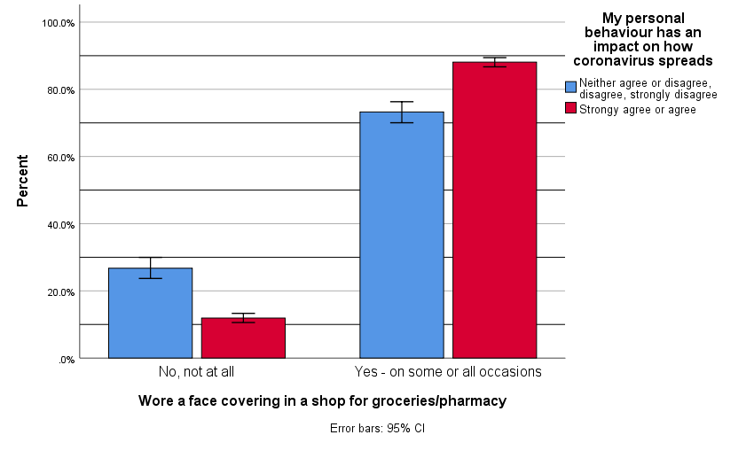
Figure 3. Wearing a face covering in a shop for groceries/pharmacy, by chance locus of control.
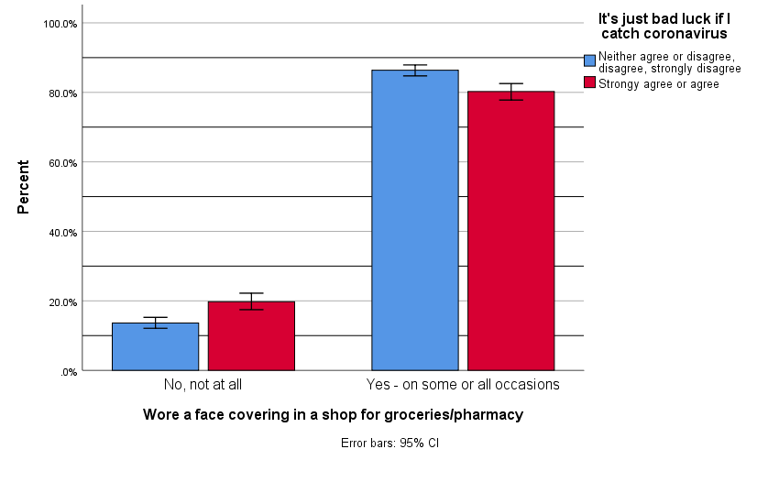

Appendices

Analyses run
Multivariable logistic regressions
Outcome variables:
- Risky social mixing (composite variable)
- Having taken a test in the last week (excluding people whose most recent test was a PCR test and who do not know what their most recent test type was, and excluding people who took a PCR and who did not know what type of test they took when symptomatic)
- Mask wearing (all or some of the time) in a shop (analyses restricted only to people who reported going out shopping in the last week)
- Hand washing (on returning home; wave 55 only)
Explanatory variables [all variables entered into the same model, therefore controlling for all other variables]:
  - Socio-demographic variables
  - Worry
  - Perceived risk: to self, to people in the UK, to friends & family
  - Locus of control
    - internal (“My personal behaviour has an impact on how coronavirus spreads”)
    - chance (“It's just bad luck if I catch coronavirus”)
    - powerful others (“My chance of catching coronavirus is largely determined by the actions of the Government”)
  - Susceptibility / severity
    - “It is likely that some of the people I come into contact with in the next seven days will have coronavirus”
    - “Coronavirus would be a serious illness for me”
  - “People who catch coronavirus are likely to have been behaving irresponsibly”
  - Perceived effectiveness items (wave 55 only)
    - For Risky social mixing: Keep the number of people you meet to a minimum; and Socialise outdoors rather than indoors
    - For Having taken a test in the last week: “Regularly testing people without symptoms is an effective way to prevent the spread of coronavirus”
    - For Mask wearing in a shop: Wear a face mask or another face covering (such as a scarf) when out and about
    - For Hand washing: Wash your hands thoroughly and regularly with soap and water, or use hand sanitising gel
  - Self-efficacy (wave 55 only)
    - For Risky social mixing: Keep the number of people you meet to a minimum; and Socialise outdoors rather than indoors
    - For Having taken a test in the last week: Book a coronavirus test if you develop symptoms
    - For Mask wearing in a shop: Wear a face mask or another face covering (such as a scarf) when out and about
    - For Hand washing: Wash your hands thoroughly and regularly with soap and water, or use hand sanitising gel

Please note that this work has been conducted rapidly and has not been peer reviewed or subject to normal quality control measures.

Dr Louise E. Smith (KCL), Professor Nicola T. Fear (KCL), Professor Henry W.W. Potts (UCL), Professor Susan Michie (UCL), Professor Richard Amlȏt (PHE), Dr G James Rubin (KCL)

Contact details: louise.e.smith@kcl.ac.uk, h.potts@ucl.ac.uk, richard.amlot@phe.gov.uk, gideon.rubin@kcl.ac.uk

There are several items in the survey asking people whether they wash their hands before or after a) going to the shops, b) travelling on public transport or in a taxi/minicab, c) going into work, d) visiting somebody else’s house, e) going to an indoor sports facility, such as a gym, f) going to a restaurant, café, or pub, g) going to a hairdresser, barbers, nail salon, beauty salon, tanning salon, or spa, and h) returning home after being out of the house. These are only asked to people who report having done that activity in the last week. Using one of these statements would lower base numbers might skew results as the sample would be limited to people who reported that activity. “Returning home after being out of the house” is the only item asked to all.

