Ethnicity, COVID-19-related behaviours, attitudes and outcomes
4th June 2020

Summary
- People identifying as BAME have generally been more worried about the coronavirus than people identifying as White.
- BAME and White individuals have had similar levels of trust in advice from the Government.
- BAME and White individuals report similar levels of handwashing.
- People identifying as BAME show lower levels of knowledge about the symptoms of COVID-19. This is partially explained by other variables (first language not being English, education level, age, having a COVID-19-relevant health condition, gender), but variation by ethnicity remains after controlling for these variables.
- People identifying as BAME are reporting higher levels of mental health problems. There are especially high levels among people who identify as Irish or as Gypsy/Traveller. This is largely explained by other variables (reported COVID-19-related poverty, reported COVID-19-related connectedness, rural vs. urban, age, having a COVID-19-relevant health condition, having a chronic mental health condition, gender). After controlling for these variables, there is little residual variation by ethnicity: people identifying as Black/Black British show lower levels of mental health problems than other groups when these other variables are matched.

Recommendations
- Public health information about COVID-19 symptoms could be better targeted at ethnic minority groups. Language difficulties may be a factor here.
- There are very high levels of mental health problems in some groups: additional help should be directed at these. The variation by ethnicity is largely related to systemic differences in society, but these cannot be immediately solved, so targeting support at ethnic minority groups would be a sensible strategy. Support should also be targeted around those in financial difficulty and those with pre-existing conditions.
- It would be useful to add a question about religion to the DHSC polling.

We have data from regular polling by DHSC. This document analyses differences by ethnicity in various variables recorded. Noting the debate over terminology, I use the term Black, Asian and Minority Ethnic (BAME) groups to match the recent Public Health England report.
In the polling, ethnicity is recorded using standard census categories. Results are either shown by BAME versus White, or a six-way categorisation where White is split into White (British/English/ Welsh/Scottish/Northern Irish) or White Other (Irish; Gypsy, Traveller or Irish Traveller; Any other White background), and BAME is split into Mixed (White and Black Caribbean; White and Black African; White and Asian; Any other Mixed/Multiple ethnic background), Asian/Asian British (Indian; Pakistani; Bangladeshi; Chinese; Any other Asian background), Black/Black British (African; Caribbean; Any other Black/African/Caribbean background) or Other (Arab; Other).
We have data on about 2000 respondents each week for 18 weeks. Some people have been polled more than once: the number is trivially small from week to week, but more significant if looking at data over all 18 weeks. Different questions were asked in different weeks.

Attitudes and behaviours about COVID-19

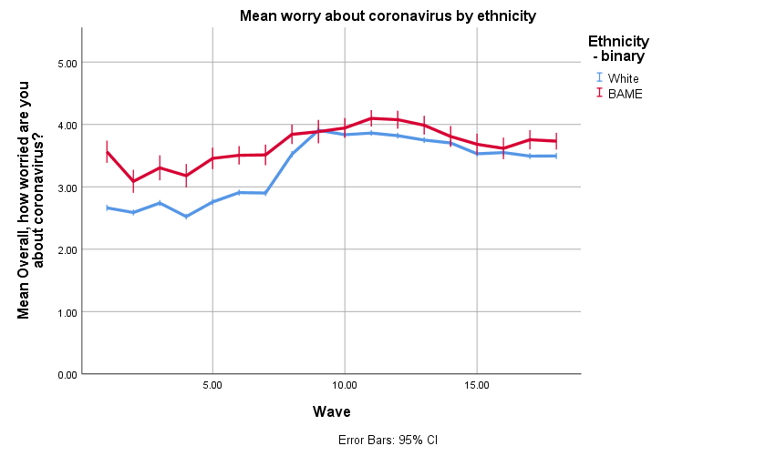
Figure: Worry about coronavirus. 5 = extremely worried; 4 = very worried; 3 = somewhat worried; 2 = not very worried; 1 = not at all worried

BAME respondents have generally been more worried about the coronavirus. In the early phase, the difference was greater, but white respondents have caught up more recently (from about week 8). We know worry is a major driver of behaviours. This should mean that BAME individuals are more likely to be appropriately protecting themselves against infection.
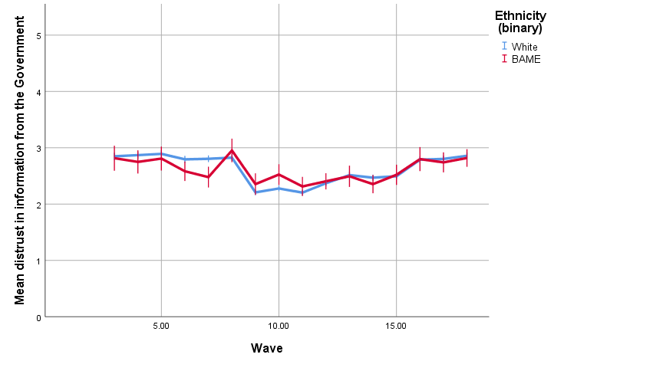
Figure: “Information from the Government about the coronavirus can be trusted”: reverse scored – 1 = strongly agree; 2 = agree, 3 = neither agree nor disagree; 4 = disagree; 5 = disagree strongly. Question not asked in first 2 waves.

BAME respondents have shown about the same trust in information from the Government.

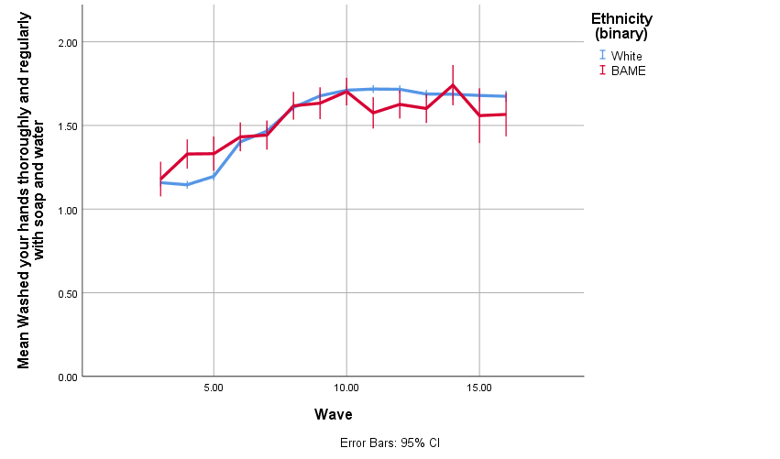
Figure: “Washed your hands thoroughly and regularly with soap and water”: 0 = not done this; 1 = done this, same amount as usual; 2 = done this, more than usual

If we look at a key desired behaviour like handwashing, we see BAME respondents are self-reporting equivalent levels of the behaviour.

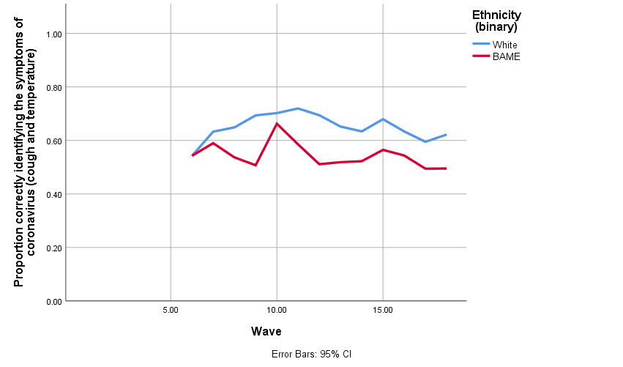

However, we can see that BAME respondents’ ability to correctly identify the symptoms of COVID-19 are below that of White respondents.

We can fit a logistic regression to predict correct identification. We include wave as a nuisance variable. There is a strong relationship with ethnicity. We fit a fuller explanatory model, also including first language not English, gender, age, having an existing LTC that makes you vulnerable, and education (binary variable).

Variable | Odds ratio | p | Adjusted odds ratio | p
Ethnicity | n/a | < 0.001 | n/a | < 0.001
White Other | 0.67 | < 0.001 | 0.76 | 0.001
Mixed | 0.55 | < 0.001 | 0.61 | < 0.001
Asian | 0.66 | < 0.001 | 0.87 | 0.13
Black | 0.64 | < 0.001 | 0.69 | 0.013
Other | 0.67 | 0.094 | 1.34 | 0.37
Education |  |  | 1.09 | 0.024
Age (per decade) |  |  | 1.22 | < 0.001
COVID-19-relevant health condition |  |  | 0.81 | < 0.001
Female vs. male |  |  | 1.57 | < 0.001
English not first language |  |  | 0.77 | 0.001

All groups other than the White group show poorer identification of symptoms. Some of this is explained in the fuller model, but we still see poorer identification by other groups.

Impact of the pandemic
We have a binary outcome measure of mental health, the PHQ4, that assess possible anxiety or depression. This is available for weeks 13-18.

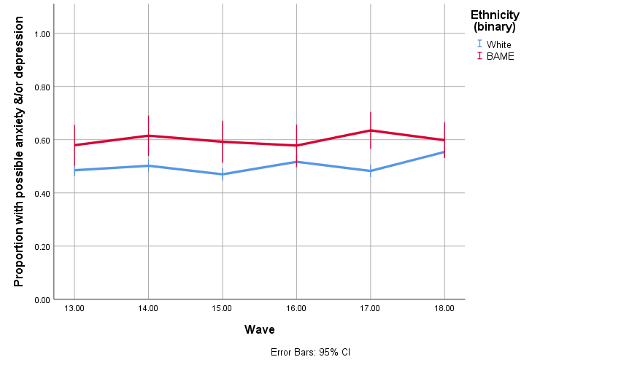

Data code | Ethnicity category | Possible psychiatric morbidity / Total | % (95% CI)
Total | TOTAL | 6133 / 12039 | 51% (51%-52%)
2 categories | White | 5490 / 10949 | 50% (49%-51%)
 | BAME | 618 / 1029 | 60% (57%-63%)
6 categories | White (1) | 4914 / 10093 | 49% (48%-50%)
 | White Other (2-4) | 576 / 856 | 67% (64%-70%)
 | Mixed (5-8) | 178 / 278 | 64% (58%-70%)
 | Asian (9-13) | 317 / 535 | 59% (55%-63%)
 | Black (14-16) | 96 / 177 | 54% (47%-62%)
 | Other (17-18) | 27 / 39 | 69% (52%-83%)
1 | British/English/Welsh/Scottish/Northern Irish | 4914 / 10093 | 49% (48%-50%)
2 | Irish | 130 / 170 | 76% (69%-83%)
3 | Gypsy, Traveller or Irish Traveller | 102 / 109 | 94% (87%-97%)
4 | Any other White background | 344 / 577 | 60% (55%-64%)
5 | White and Black Caribbean | 50 / 87 | 57% (46%-68%)
6 | White and Black African | 41 / 54 | 76% (62%-87%)
7 | White and Asian | 55 / 82 | 67% (56%-77%)
8 | Any other Mixed/Multiple ethnic background | 32 / 55 | 58% (44%-71%)
9 | Indian | 127 / 206 | 62% (55%-68%)
10 | Pakistani | 70 / 125 | 56% (47%-65%)
11 | Bangladeshi | 34 / 48 | 71% (56%-83%)
12 | Chinese | 35 / 77 | 45% (34%-57%)
13 | Any other Asian background | 51 / 79 | 65% (53%-75%)
14 | African | 61 / 107 | 57% (47%-67%)
15 | Caribbean | 32 / 63 | 51% (38%-64%)
16 | Any other Black/African/Caribbean background | 3 / 7 | 43% (10%-82%)
17 | Arab | 14 / 17 | 82% (57%-96%)
18 | Other | 13 / 22 | 59% (36%-79%)
19 | Don’t know | 0 / 1 | n/a
20 | Prefer not to say | 25 / 60 | 42% (29%-55%)

When we compare White and BAME respondents, we see higher rates of possible morbidity in the BAME individuals (Fisher exact test, p < 0.001).

We can sub-divide the groups further. Again, we see rates differing between groups (Χ²(5) = 151.9, p < 0.001). Asian, Mixed, White Other and Other respondents show higher rates than White respondents. The rate among Black respondents is in between and not statistically significantly different from most other groups.

Looking at the individual categories, we see the Any Other White category showing higher rates than British/English/Welsh/Scottish/Northern Irish respondents, Irish respondents showing higher rates still, and Gypsy/Traveller respondents showing exceedingly high rates.
We can build a logistic regression model predicting possible morbidity. This was based on prior analyses and Smith et al. (2020; doi: 10.1016/j.psychres.2020.113138).
Variable | Odds ratio | p | Adjusted odds ratio | p
Ethnicity | n/a | < 0.001 | n/a | 0.004
White Other | 2.17 | < 0.001 | 1.22 | 0.065
Mixed | 1.88 | < 0.001 | 0.92 | 0.64
Asian | 1.53 | < 0.001 | 0.83 | 0.14
Black | 1.25 | 0.14 | 0.49 | 0.001
Other | 2.37 | 0.013 | 1.06 | 0.90
Reported COVID-19-related poverty |  |  | 1.38 | < 0.001
Reported COVID-19-related connectedness |  |  | 0.85 | < 0.001
Rural vs. urban |  |  | 0.80 | 0.001
Age (per decade) |  |  | 0.81 | < 0.001
COVID-19-relevant health condition |  |  |  | 0.002
Having a chronic mental health condition |  |  | 5.38 | < 0.001
Female vs. male |  |  | 1.94 | < 0.001

In a basic model with just ethnicity as a predictor, we see elevated rates of possible psychiatric morbidity compared to the White reference group in all groups except Black. However, when we control for other variables, we now see Black respondents have lower rates of possible psychiatric morbidity considering other factors in their lives. The White Other group has a marginally higher rate of possible psychiatric morbidity considering other factors in their lives.
That is, most of the variation between ethnic groups in possible psychiatric morbidity is related to factors including poverty, connectedness, urban vs. rural living, age, gender, and existing physical and mental health conditions. Taking those into account, Black respondents show higher resilience, while White Other respondents may show higher rates of possible morbidity.
We also have a measure of financial difficulties for later survey waves. This measure combines answers to the following questions: “I am struggling to make ends meet”, “I am skipping meals I would usually have”, and “I am finding my current living situation difficult”.
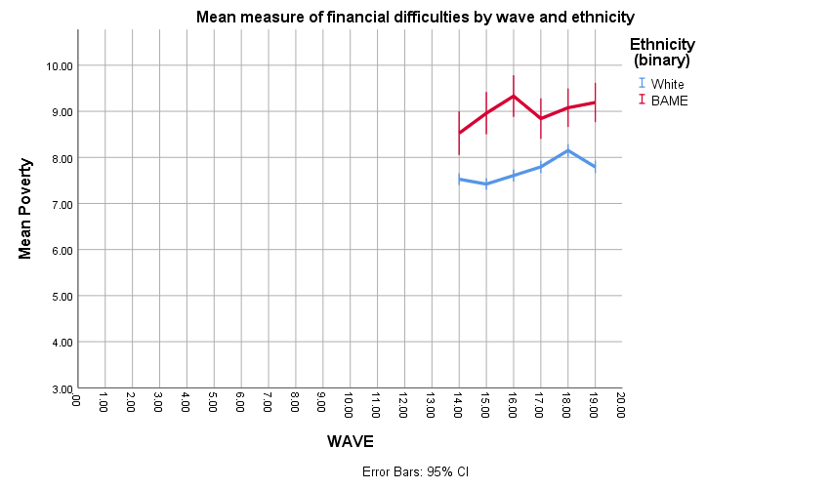

BAME individuals show greater difficulties here. Most groups show greater difficulties, except people identifying as Chinese.

Data code | Ethnicity category | Mean | 95% CI
1 | British/English/Welsh/Scottish/Northern Irish | 7.6 | 7.6-7.7
2 | Irish | 9.1 | 8.6-9.6
3 | Gypsy, Traveller or Irish Traveller | 10.1 | 9.7-10.6
4 | Any other White background | 8.3 | 8.1-8.5
5 | White and Black Caribbean | 8.3 | 7.7-9.0
6 | White and Black African | 9.8 | 9.1-10.4
7 | White and Asian | 9.4 | 8.8-10.1
8 | Any other Mixed/Multiple ethnic background | 8.4 | 7.8-9.1
9 | Indian | 9.3 | 8.9-9.6
10 | Pakistani | 9.5 | 9.0-9.9
11 | Bangladeshi | 9.2 | 8.4-10.0
12 | Chinese | 7.3 | 6.5-8.1
13 | Any other Asian background | 9.1 | 8.6-9.7
14 | African | 8.8 | 8.2-9.4
15 | Caribbean | 8.6 | 7.9-9.4
16 | Any other Black/African/Caribbean background | 9.3 | 4.2-14.5
17 | Arab | 9.5 | 7.9-11.0
18 | Other | 9.8 | 8.3-11.3
20 | Prefer not to say | 8.5 | 7.8-9.2

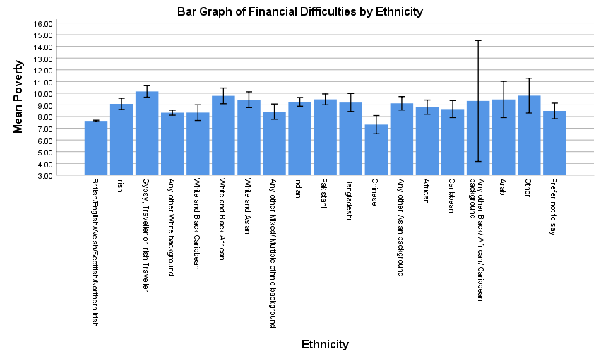

Datasets used:
- Department of Health and Social Care weekly tracker
  - Tracking DHSC marketing, coronavirus attitudes, beliefs, knowledge, reported behaviour, satisfaction with Government response, credibility of Government.
  - Data collected weekly (Monday to Wednesday) since late January.
  - Market research company commissioned: BMG Research.

Please note that this work has been conducted rapidly, and has not been peer reviewed or subject to normal quality control measures.

Dr Henry W.W. Potts (UCL), Dr Louise E. Smith (KCL), Professor Nicola T. Fear (KCL), Professor Susan Michie (UCL), Professor Richard Amlȏt (PHE), Dr G James Rubin (KCL)

Contact details: h.potts@ucl.ac.uk, louise.e.smith@kcl.ac.uk, richard.amlot@phe.gov.uk, gideon.rubin@kcl.ac.uk,

