At risk groups
Louise E Smith, 21 December 2021

- People with certain medical conditions are at higher risk from COVID-19,¹ as are older people.
- We report analyses investigating the influence of the emergence of the Omicron variant of concern elsewhere.²
- People at risk of COVID-19 were less likely to report having been shopping in the last week than those not at risk. There were no differences in other out-of-home activities (shopping for other items, meeting up with people from another household, visiting hospitality venues, and using public transport or a taxi/minicab).
- In those at risk of COVID-19, there were no changes in out-of-home activity between 29 November to 16 December 2021, spanning the emergence of the Omicron variant.
- There were no differences in patterns of social mixing over time in people at risk of COVID-19.
- Older people (aged 65 years and over) were less likely to report having been shopping for groceries/pharmacy, shopping for other items, visiting hospitality venues, and using public transport or a taxi/minicab than younger participants. There was no difference in the reported number of times meeting up with people from another household.
- Older participants’ shopping behaviour (for groceries/pharmacy) decreased from 29 November to 16 December 2021, spanning the emergence of the Omicron variant. There were no other changes in out-of-home activity.
- There were no differences in patterns of social mixing over time in older people.

At risk – medical condition
People at risk of COVID-19 were less likely to go shopping than those not at risk (been to the shops, for groceries/pharmacy (U=2038350.50, p=0.004), at risk: mean=2.6, SD=3.6, median=2, not at risk: mean=2.6, SD=3.1, median=2; been to the shops, for things other than groceries/pharmacy (U=2043331.00, p=0.004), at risk: mean=1.2, SD=2.7, median=0, not at risk: mean=1.3, SD=2.7, median=1). There were no other differences in out-of-home activity in those who were at risk of COVID-19 compared to those not at risk (met up with people from another household (U=2156202.50, p=0.94); been to a restaurant, café or pub (U=2115706.00, p=0.27) use of public transport or being in a taxi/minicab (U=2109182.50, p=0.18)).
There were no significant differences in out-of-home activity over time (been to the shops, for groceries/pharmacy (χ²(2)=2.9, p=0.24); been to the shops, for things other than groceries/pharmacy (χ²(2)=2.3, p=0.31); met up with people from another household (χ²(2)=2.4, p=0.30); been to a restaurant, café or pub (χ²(2)=1.7, p=0.43) use of public transport or being in a taxi/minicab (χ²(2)=3.1, p=0.21); Figure 1).
Figure 1. Out-of-home activity in at-risk participants, between 29 November and 16 December 2021.
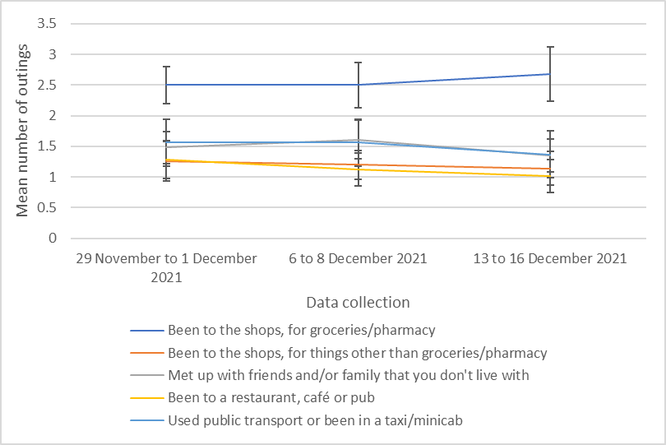

There were no differences in social mixing over time, stratified by risk of transmission (negligible risk (χ²=1.7 (2), p=.44); lowest risk (χ²=3.4 (2), p=.18); medium risk (χ²=0.5 (2), p=.78); or highest risk (χ²=0.1 (2), p=0.99; n=1049; Figure 2).

Figure 2. Risky social mixing in at-risk participants, between 29 November and 16 December 2021.
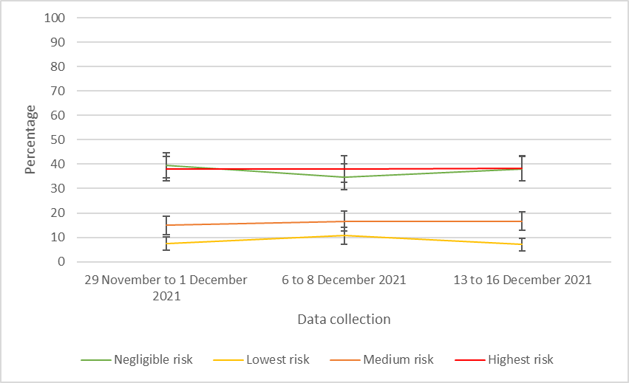

Older age
Older people reported fewer outings than younger people (been to the shops, for groceries/pharmacy (U=2297968.0, p<.001), older: mean=2.2, SD=2.3, median=2, younger: mean=2.7, SD=3.4, median=2; been to the shops, for things other than groceries/pharmacy (U= 2100314.0, p<.001), older: mean=0.8, SD=1.5, median=0, younger: mean=1.5, SD=2.9, median=1; been to a restaurant, café or pub (U= 2287851.0, p<.001), older: mean=0.8, SD=1.5, median=0, younger: mean=1.2, SD=2.4, median=1; used public transport or been in a taxi/minicab (U= 2134362.0, p<.001), older: mean=0.7, SD=1.8, median=0, younger: mean=1.4, SD=3.1, median=0), except for meeting up with people from another household, where there was no difference (U= 2489725.0, p=.50).
Going to the shops for groceries/pharmacy decreased over time (χ²(2)=8.6, p=0.01; Figure 3). There were no other significant differences in out-of-home activity over time (been to the shops, for things other than groceries/pharmacy (χ²(2)=1.9, p=0.38); met up with people from another household (χ²(2)=2.8, p=0.25); been to a restaurant, café or pub (χ²(2)=0.5, p=0.77); used public transport or been in a taxi/minicab (χ²(2)=0.3, p=0.85)).
Figure 3. Out-of-home activity in older participants, between 29 November and 16 December 2021.
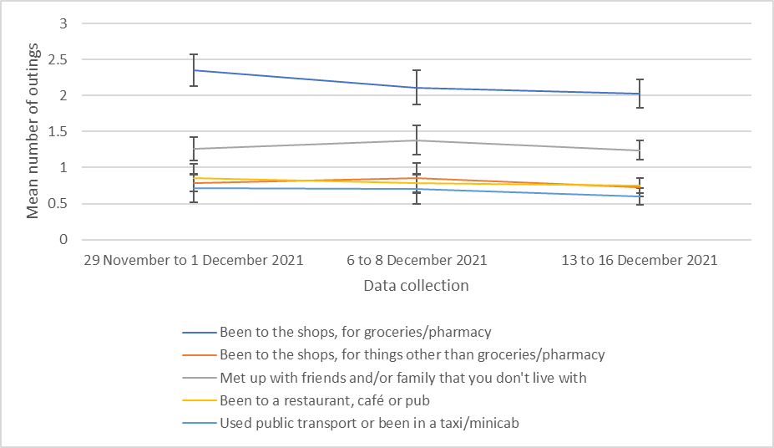
There were no differences in social mixing over time, stratified by risk of transmission (negligible risk (χ²=3.5 (2), p=.18); lowest risk (χ²=3.8 (2), p=.15); medium risk (χ²=0.2 (2), p=.89); or highest risk (χ²=0.4 (2), p=0.81; n=1256; Figure 4).

Figure 4. Risky social mixing in older participants, between 29 November and 16 December 2021.
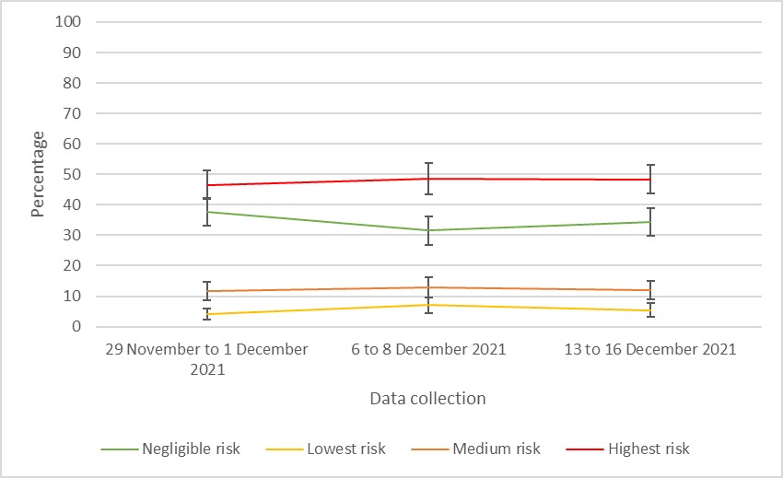

Limitations:
- We are unsure whether the beliefs and behaviours of survey respondents is representative of that of the general population. This is especially relevant for older participants. While internet usage has risen recently, 84.4% of women and 86.6% men aged 65 to 74 years, have used the internet in the last three months.³ For those aged 75+ years, 49.8% women and 59.4% men have used the internet in the last three months.
- We limited the sample to those who reported a medical condition that puts them at risk of COVID-19, and to older adults. This has resulted in a smaller sample size, resulting in large confidence intervals.
- We coded people as being at high risk of COVID-19 based on participants’ self-report of relevant health conditions. These do not match up exactly to those identified by the NHS.¹ In some cases, the NHS identifies people with “severe” conditions as being at risk, whereas this distinction is not made in the survey. We coded people as being “at high risk” if they reported having diabetes (type 1 or 2); epilepsy; Chronic Obstructive Pulmonary Disease (COPD), including emphysema and chronic bronchitis; asthma; heart conditions; chronic kidney disease; chronic liver disease and cirrhosis; a condition affecting their brain and nerves, such as Parkinson's disease, motor neurone disease, multiple sclerosis (MS), a learning disability or cerebral palsy; recovering from a stroke; a condition that makes them much more likely to get infections (e.g. SCID, homozygous sickle cell); having had an organ transplant; having had a bone marrow or stem cell transplant in the last 6 months; taking medicine that weakens your immune system (e.g. steroid tablets, chemotherapy, or antiretroviral medications); HIV/AIDS; or being very overweight.

Methods
- We used the CORSAIR study,⁴ to investigate self-reported behaviour in people at higher risk of COVID-19 due to a medical condition or older age (65 years and older). Sample limited to participants living in England.
- Table 1 shows number of participants included in analyses.
Table 1. Numbers of participants per wave.
 | Data collected | At risk, n | Older age (65 years and over), n | Total sample (England only), n
Wave 63 | 29 November to 1 December 2021 | 363 | 450 | 1743
Wave 63.5 | 6 to 8 December 2021 | 319 | 381 | 1680
Wave 64 | 13 to 16 December 2021 | 368 | 427 | 1841

- Participants were asked how many times in the last week they had done each of a list of twenty activities including shopping for groceries/pharmacy; shopping for other items; providing help or care for a vulnerable person; meeting up with friends or family that they did not live with; going to a restaurant, café or pub; using public transport or a taxi/minicab; and going out to work. Responses were capped at 30.
- Participants who indicated that they had met up with friends or family from another household were asked a series of follow-up questions about the setting and number of people involved in their most recent meeting in the past seven days. We derived a measure categorising the risk of transmission involved in a participant’s most recent instance of social mixing.⁵
- Due to skewed outcomes, we used non-parametric tests to assess differences between groups (2 groups: Mann Whitney test, 3 groups: Kruskal-Wallis test).
Dataset used:
- Department of Health and Social Care weekly tracker
  - Tracking reported behaviour.
  - Data collected weekly (Monday to Wednesday).
  - N~2000 per wave.
  - Market research company commissioned: Savanta.

References
1. NHS. Who is at high risk from coronavirus (COVID-19). 9 December 2021 2021. https://www.nhs.uk/conditions/coronavirus-covid-19/people-at-higher-risk/who-is-at-high-risk-from-coronavirus/ (accessed 20 December 2021.
2. Smith LE, Potts HWW, Amlȏt R, Fear N, Michie S, Rubin GJ. How has the emergence of the Omicron SARS-CoV-2 variant of concern influenced worry, perceived risk, and behaviour in the UK? The COVID-19 Rapid Survey of Adherence to Interventions and Responses (CORSAIR) study. Open Science Framework 2021.
3. Office for National Statistics. Internet users, UK: 2020. 6 April 2021 2021. https://www.ons.gov.uk/businessindustryandtrade/itandinternetindustry/bulletins/internetusers/2020 (accessed 20 December 2021.
4. Smith LE, Potts HWW, Amlot R, Fear NT, Michie S, Rubin GJ. Adherence to the test, trace, and isolate system in the UK: results from 37 nationally representative surveys. BMJ 2021; 372: n608.
5. Smith LE, Potts HWW, Amlȏt R, Fear N, Michie S, Rubin GJ. How have patterns of social mixing changed during the pandemic? A series of cross-sectional nationally representative surveys. Open Science Framework 2021.

Please note that this work has been conducted rapidly and has not been peer reviewed or subject to normal quality control measures.

Dr Louise E. Smith (KCL), Professor Nicola T. Fear (KCL), Professor Henry W.W. Potts (UCL), Professor Susan Michie (UCL), Professor Richard Amlȏt (PHE), Dr G James Rubin (KCL)

Contact details: louise.e.smith@kcl.ac.uk, h.potts@ucl.ac.uk, gideon.rubin@kcl.ac.uk

Supplementary materials
Figure 1. Timeline of announcements, data collection, and dates of self-reported behaviours.
24-Nov | Omicron variant reported to WHO |  | Wave 63 “past seven days” could cover
25-Nov
26-Nov | Omicron designated a variant of concern
27-Nov | New measures announced  First UK cases
28-Nov
29-Nov |  | Wave 63 |  | Wave 63.5 “past seven days” could cover
30-Nov | New measures take effect  Daily Mirror breaks ‘Partygate’
01-Dec
02-Dec
03-Dec | Omicron cases in the UK exceed 100
04-Dec
05-Dec
06-Dec |  | Wave 63.5 |  |  | Wave 64 “past seven days” could cover
07-Dec | ITV reports on a video seeming to confirm ‘Partygate’
08-Dec | “Plan B” announced
09-Dec
10-Dec
11-Dec
12-Dec
13-Dec | “Plan B” mostly takes effect  First UK death from Omicron | Wave 64
14-Dec
15-Dec | UK records its highest number of daily cases (78,610)
16-Dec | UK records its highest number of daily cases (88,376)

