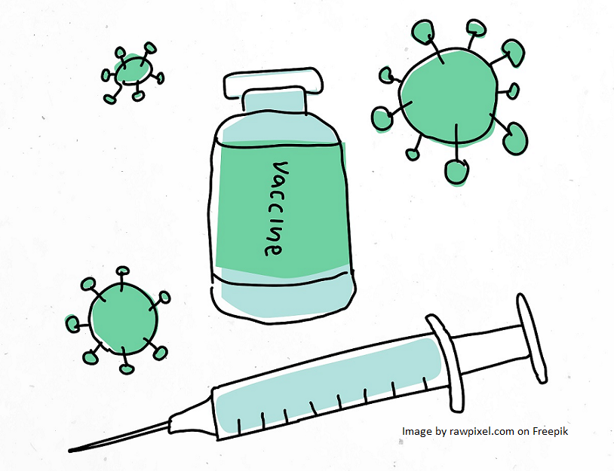
Adolescent attitudes to vaccines and side effects

INFORMATION SHEET FOR TEENAGERS (1)

- You’re invited to take part in research about teenage attitudes towards vaccines and side-effects.
- You’ve been invited because you are aged 12-15, and are in school years 8, 9 or 10 in England.
- If you don’t want to participate or don’t feel comfortable talking about vaccines, that’s fine – you can say no!
- This is not a test and there are no right or wrong answers. We want to hear YOUR OPINION as your opinions matter. What’s most important is that we hear what you really think, whether you’ve said yes or no to vaccines.
- We’re NOT trying to persuade you to have vaccinations, we just want to know what you think.
- You can take part either on your own, or with a friend. If you want to take part with a friend (and they are happy to join in), please ask them to contact us at angie.pitt@kcl.ac.uk including their parent/ guardian in the email.
- You can choose to take part until 15th March 2024.
- You (or your parent/guardian) can change your mind about taking part in this research without having to give a reason at any time up until 31st March 2024, by emailing angie.pitt@kcl.ac.uk and saying you no longer wish to take part. This would mean that all the information you have given us will be deleted.
- If you are chosen to have a chat with the researcher, we’ll give you a £20 Amazon voucher as a thank you for your time.

If you want to take part:

- If you haven’t already, complete an online screening survey linked to here: https://epr.hpru.nihr.ac.uk/news/teenagers-and-vaccinations . Let us know if you can’t access it and we’ll post you a copy instead. This survey must be completed by you, but you can ask a parent/guardian for help if you need to.
- Return the assent form (form 4 – completed by you) and the consent form (form 3 - completed by a parent/guardian) to us, including your parent/guardian in the email. You can do this by sending a photo or scan of the form to angie.pitt@kcl.ac.uk.
- We will choose participants based on the information you give us in the survey. This is to make sure that we include as broad a range of teenage voices as possible in this research.
- If you are selected to be interviewed, we will contact you to arrange an online chat at a time that suits you (and doesn’t clash with school lessons, clubs, or hobbies). We’ll ask you to be interviewed without a parent/guardian present so that we make sure we hear what YOU think!
- This chat will last 30-45 minutes (or 45-60 minutes if you are being interviewed in a pair) and will be on Microsoft Teams. If you don’t have access to the internet, we can carry out interviews on the telephone. Questions will cover whether you’ve had vaccines in the past, how you decide whether to have a vaccine, what you think about side effects from vaccines, and where you might go for more information about vaccines and side effects.
- We’ll record our conversation and afterwards will ask a separate company to write it out word for word (transcribe it). Once it is written it up and your name has been removed, the recording will be deleted.
- We’ll use this research in a university essay, in presentations and it may be published in research magazines. You will never be identified in this work, even if we directly quote you.

If you have any questions or would like some more information about this project, please contact Angie Pitt at angie.pitt@kcl.ac.uk making sure you copy in a parent or guardian.

Thank you for reading this and for considering taking part in this research.
With thanks to pupils at Ark Walworth Academy who co-produced this document.

