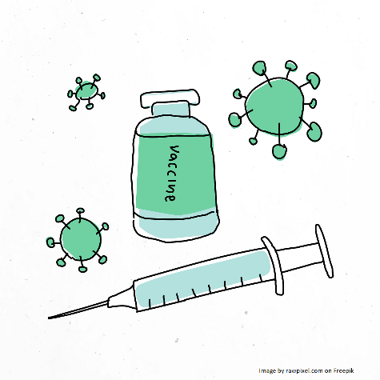

ASSENT FORM (4):
Adolescent attitudes to vaccines and side effects

This is called an assent form. This means that, although legally your parent or guardian must consent to you taking part in our study, you still have a say on whether to assent (agree to take part) or dissent (refuse to take part). Please complete this form after you have read and discussed the information with your parent or guardian. If you have any questions email us at angie.pitt@kcl.ac.uk (including your parent/guardian in the email).
 | Please circle yes or no for each question
- I confirm that I have read the information sheet (Form 1) and discussed the research with my parent/guardian. | YES / NO
- I confirm that I am happy to take part in the research. | YES / NO
- I understand that I (or my parent/guardian) can change my mind about taking part at any time without having to give a reason, until 31st March 2024. If I change my mind, I will let you know by emailing angie.pitt@kcl.ac.uk (including a parent or guardian in the email). If I change my mind and let Angie know, all my data will be deleted. | YES / NO
- I understand that you will keep what I say and information about me confidential, and not share it in a way that would allow other people to identify me. | YES / NO
- I understand that I can choose to take part in the chat in a pair with a friend, and that if I do you will ask us both to keep what is said in our chat confidential, but cannot guarantee that my friend will do so. | YES / NO
- I agree to our chat being audio and video recorded. | YES / NO
- I agree to you including direct quotes from me in your research, but understand that you won’t identify me by name, school name or image when quoting me. | YES / NO
- I agree to you sharing my data with an external company so that they can write out word for word what we said, to help the researchers go over the conversation again afterwards. | YES / NO

_____________________ __________________ _________________
Your name Date Signature

_____________________ __________________ _________________
Researcher’s name Date Signature

With thanks to pupils at Ark Walworth Academy who co-produced this form.

