Physical distancing and related behaviours: changes over time
16th June 2020

Key findings
We used DHSC polling data to investigate changes in physical distancing and related behaviours over time.
- Total number of outings is increasing. The number of outings for different reasons (e.g. to shop for groceries / pharmacy, to shop for items other than groceries / pharmacy, to go out to work, and to help or provide care for a vulnerable person) are stable over time. The number of outings to meet friends and family, and to spend time outdoors for recreational purposes, is increasing steadily.
- The proportion of people who report having come into close contact with others when out is relatively stable over time.
- Higher total number of outings was associated with lower perceived effectiveness of staying 2m (3 steps) away from others as a way to prevent the spread of coronavirus, and lower confidence that if you wanted to you could stay 2m (3 steps away from others).
- Coming into close contact with others while out and about more often was associated with lower perceived effectiveness of staying 2m (3 steps) away from others as a way to prevent the spread of coronavirus, lower confidence that if you wanted to you could stay 2m (3 steps away from others), and not having heard advice to keep your distance from other people if you go out.
- Reporting wearing a face covering or protective gloves while out and about was associated with fewer total outings in the last week.
- Reporting wearing a face covering or protective gloves while out and about was associated with coming into close contact with others while out and about more often.

Figure 1. Graph depicting the total mean number of outings made in the last week to go shopping for groceries/pharmacy, to go shopping for items other than groceries/pharmacy, to go to work, to help or provide care for a vulnerable person and to meet up with friends or family that you do not live with.
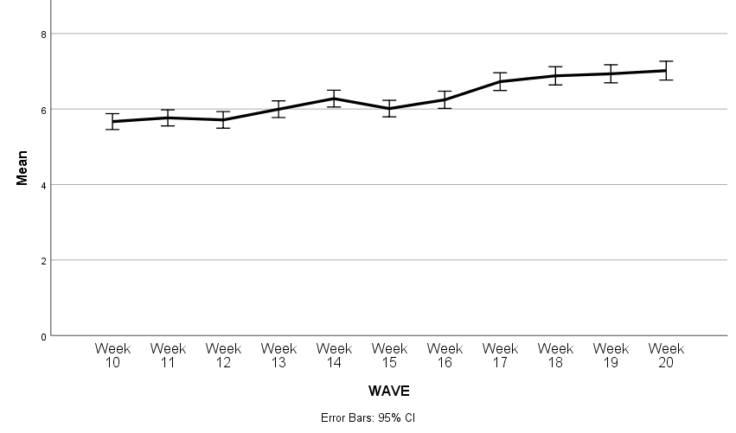

Median split on the number of out of home outings (6 and below, 7 and above). Associations analysed using chi-squared statistics:
- No difference in total out-of-home behaviour by having seen advice to limit your contact with other people, and to keep your distance from other people if you go out.
- Those who thought an effective way to prevent the spread of coronavirus was to stay 2m (3 steps) away from others outside their household had a lower number of out-of-home outings.
- Those who were confident that if they wanted to, they could, stay 2m (3 steps) away from others outside their household had a lower number of out-of-home outings.
- People who have worn a mask or face covering more frequently while out and about had a lower number of out-of-home outings.
- People who have worn protective gloves more frequently while out and about had a lower number of out-of-home outings.

Figure 2. Graph depicting the proportion of people who have been out in the last week to shop for groceries/pharmacy (twice or more), to shop for items other than groceries/pharmacy, to go out to work, to help or provide care for a vulnerable person, and to meet friends or family that they did not live with.
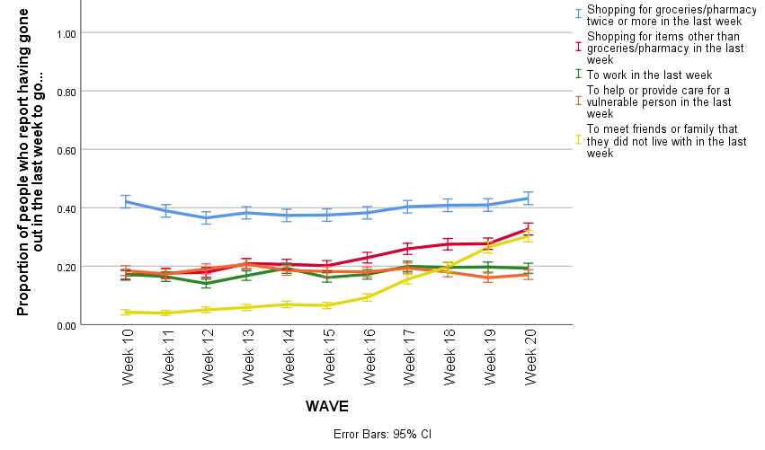

Figure 3. Graph depicting the proportion of people who have been out in the last week to shop for groceries/pharmacy (twice or more), to shop for items other than groceries/pharmacy, to go out to work, to help or provide care for a vulnerable person, and to meet friends or family that they did not live with.
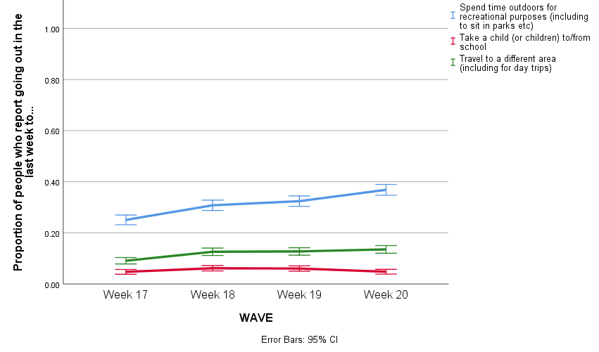

Figure 4. Graph depicting the proportion of outings in which a participant came into close contact with others (w12 data missing from the dataset delivered).

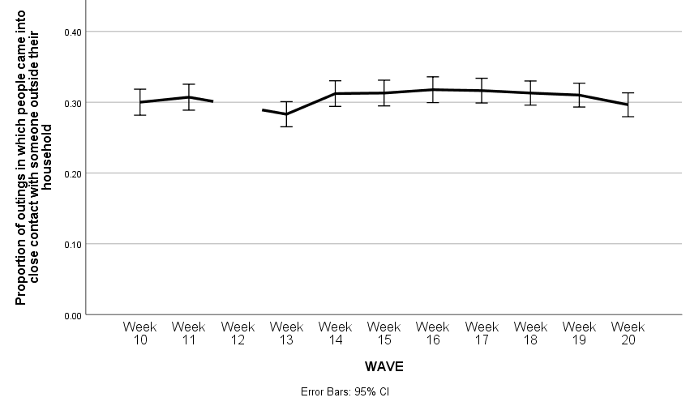

Associations were analysed using chi-squared statistics (been in close contact with someone in half or more outings vs been in close contact with someone in less than half of outings):
- Those who had seen / heard advice to limit your contact with other people, and to keep your distance from other people if you go out were less likely to come into close contact with others while out.
- Those who thought an effective way to prevent the spread of coronavirus was to stay 2m (3 steps) away from others outside their household were less likely to come into close contact with others while out.
- Those who were confident that if they wanted to, they could, stay 2m (3 steps) away from others outside their household were less likely to come into close contact with others while out.
- People who have worn a mask or face covering more frequently while out and about were more likely to come into close contact with others while out.
- People who have worn protective gloves more frequently while out and about were more likely to come into close contact with others while out.
Figure 5. Graph depicting the mean number of people someone has come into close contact with in the last week, over time.
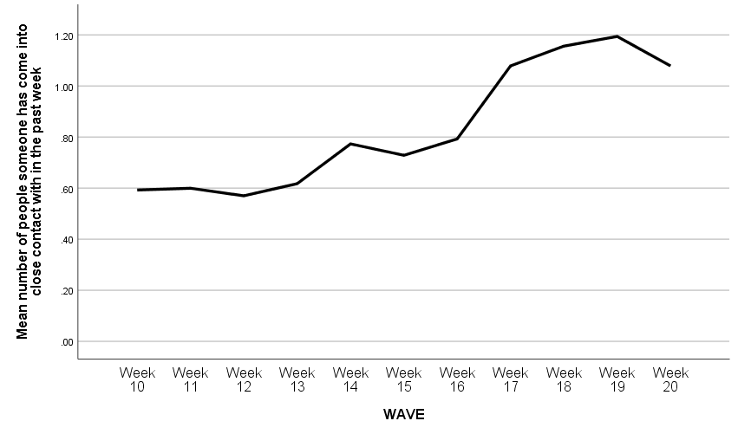

Figure 6. Graph depicting proportion of people who had seen or heard advice to limit your contact with other people, and to keep your distance from other people if you go out.
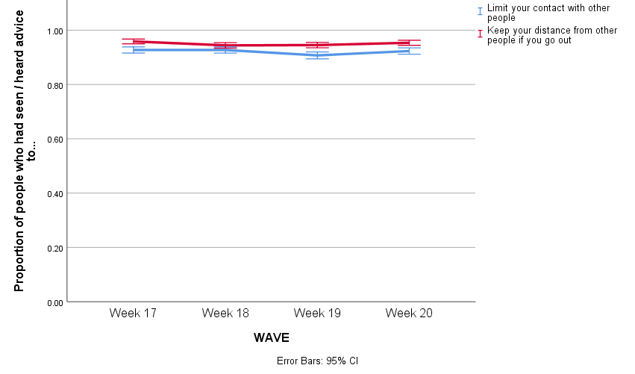

Figure 7. Graph depicting perceived effectiveness and confidence that if you wanted to, you could, stay 2m (3 steps) away from people not in your household when out and about.
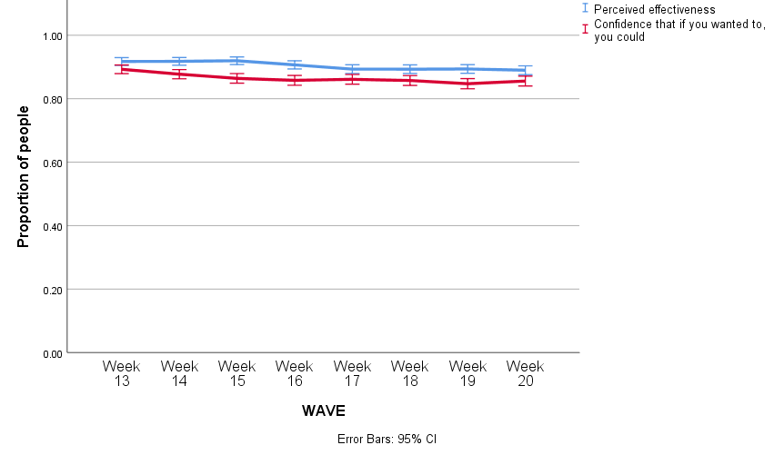

Datasets used:
- Department of Health and Social Care weekly tracker
  - Tracking DHSC marketing, coronavirus attitudes, beliefs, knowledge, reported behaviour, satisfaction with Government response, credibility of Government.
  - Data collected weekly (Monday to Wednesday) since late January.
  - N~2000 per wave.
  - Market research company commissioned: BMG Research.
- Data collection dates:
Wave 10 | 30 March - 1 April
Wave 11 | 6 - 8 April
Wave 12 | 14 - 15 April
Wave 13 | 20 - 22 April
Wave 14 | 27 - 29 April
Wave 15 | 4 - 6 May
Wave 16 | 11 - 13 May
Wave 17 | 18 – 20 May
Wave 18 | 25 – 27 May
Wave 19 | 1 – 3 June
Wave 20 | 8 – 10 June

Please note that this work has been conducted rapidly, and has not been peer reviewed or subject to normal quality control measures.

Dr Louise E. Smith (KCL), Professor Nicola T. Fear (KCL), Dr Henry W.W. Potts (UCL), Professor Susan Michie (UCL), Professor Richard Amlȏt (PHE), Dr G James Rubin (KCL)

Contact details: louise.e.smith@kcl.ac.uk, richard.amlot@phe.gov.uk, gideon.rubin@kcl.ac.uk

