Graphs of validated measures
23 June 2021

PHQ-4
- The PHQ4 is a valid tool for detecting anxiety and depressive disorders. Higher scores are associated with increased mental distress. Scores of 0 to 2 are rated “normal” [range 0 to 12].(1)
- Normative data for the PHQ4 can be derived from a representative German population,(2) and from the UK BioBank (NB-restricted age range [37 to 73 years]).(3) In these groups, approximately 75% of the population show no mental distress (scores of 0 to 2).
- We can split results from the PHQ4 to indicate probable anxiety and probable depression.
- Mental distress, probable anxiety and probable depression across the pandemic are charted in Figure 1.
Figure 1. Probable mental distress, as measured by the PHQ4.
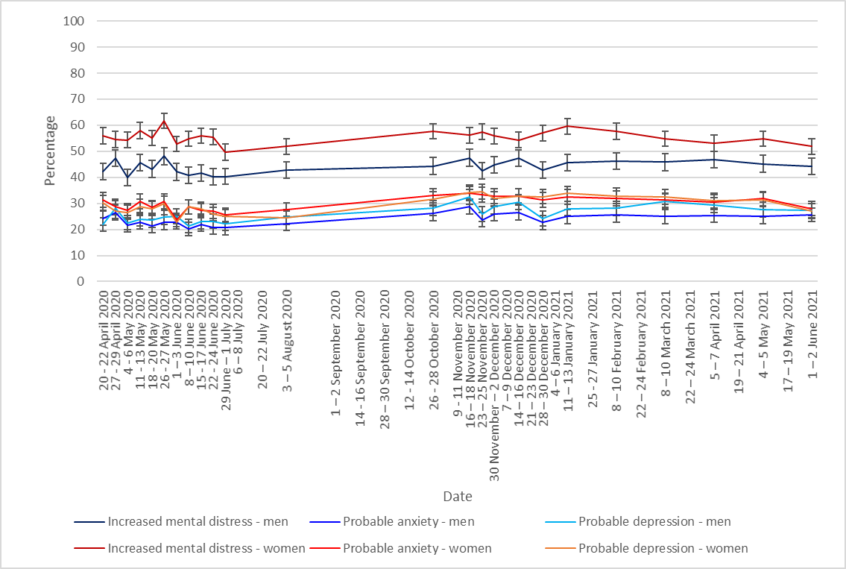
- A different study conducted during the pandemic also used the PHQ4 to measure probable anxiety and depression in the general population in the UK (data collected 6-7 May 2020).(4) This study also found similar results, with 22% of the sample reported probable anxiety, and 24% reported probable depression.

Short Warwick-Edinburgh Mental Wellbeing Scale (SWEMWS)
- The Short Warwick-Edinburgh Mental Wellbeing Scale (SWEMWS) is a validated tool for measuring wellbeing (score ranges from 7 to 35). Higher scores are associated with better mental wellbeing. Scores for the SWEMWS (7 items) can be transformed to facilitate comparison with the Warwick-Edinburgh Mental Wellbeing Scale (14 items).(5)
- Normative data for the SWEMWS in the UK population indicates the (transformed) mean score for women is 23.2 and the mean score for men is 23.7.(6)
- Mean wellbeing scores, by gender, as measured by the transformed SWEMWS are shown in Figure 2.

Figure 2. Mean wellbeing scores, by gender, as measured by the SWEMWS (data transformed).

Alcohol Use Disorders Identification Test (AUDIT-C)
- AUDIT-C is a validated tool that can identify those who are problematic drinkers (those who are hazardous drinking or who have active alcohol use disorders; those with a score of 5 or above).(7, 8) Higher scores are associated with problematic drinking.
- Alcohol consumption is higher in men than women.(9)
- The percentage of people who reported hazardous drinking during the pandemic is shown in Figure 3.

Figure 3. Percentage of people who reported hazardous drinking during the pandemic.
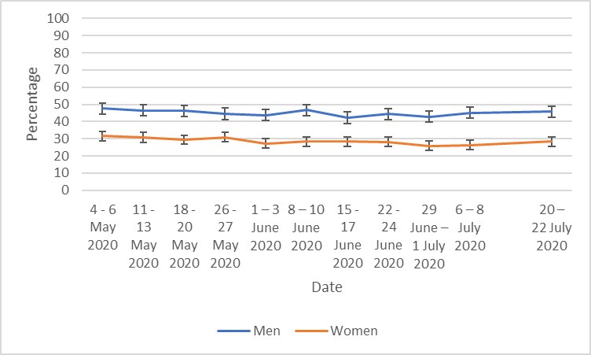

References
1. Kroenke K, Spitzer RL, Williams JB, Lowe B. An ultra-brief screening scale for anxiety and depression: the PHQ-4. Psychosomatics. 2009;50(6):613-21.
2. Lowe B, Wahl I, Rose M, Spitzer C, Glaesmer H, Wingenfeld K, et al. A 4-item measure of depression and anxiety: validation and standardization of the Patient Health Questionnaire-4 (PHQ-4) in the general population. J Affect Disord. 2010;122(1-2):86-95.
3. Batty GD, McIntosh AM, Russ TC, Deary IJ, Gale CR. Psychological distress, neuroticism, and cause-specific mortality: early prospective evidence from UK Biobank. J Epidemiol Community Health. 2016;70(11):1136-9.
4. Smith LE, Amlot R, Lambert H, Oliver I, Robin C, Yardley L, et al. Factors associated with self-reported anxiety, depression, and general health during the UK lockdown; a cross-sectional survey. MedRxiv. 2020.
5. Stewart-Brown S, Tennant A, Tennant R, Platt S, Parkinson J, Weich S. Internal construct validity of the Warwick-Edinburgh Mental Well-being Scale (WEMWBS): a Rasch analysis using data from the Scottish Health Education Population Survey. Health Qual Life Outcomes. 2009;7:15.
6. Ng Fat L, Scholes S, Boniface S, Mindell J, Stewart-Brown S. Evaluating and establishing national norms for mental wellbeing using the short Warwick-Edinburgh Mental Well-being Scale (SWEMWBS): findings from the Health Survey for England. Qual Life Res. 2017;26(5):1129-44.
7. Alcohol screening tool [Available from: https://www.gmmh.nhs.uk/download.cfm?doc=docm93jijm4n639.pdf&ver=1017.
8. Public Health England. Guidance on the 5 alcohol use screening tests 2020 [updated 30 October 2020. Available from: https://www.gov.uk/government/publications/alcohol-use-screening-tests/guidance-on-the-5-alcohol-use-screening-tests.
9. Office for National Statistics. Part 4: Drinking behaviours among adults 2020 [updated 30 January 2020. Available from: https://digital.nhs.uk/data-and-information/publications/statistical/statistics-on-alcohol/2020/part-4.

Datasets used:
- Department of Health and Social Care weekly tracker
  - Tracking DHSC marketing, coronavirus attitudes, beliefs, knowledge, reported behaviour, satisfaction with Government response, credibility of Government.
  - Data collected weekly (Monday to Wednesday) since late January.
  - N~2000 per wave.
  - Market research company commissioned: BMG Research.

Please note that this work has been conducted rapidly and has not been peer reviewed or subject to normal quality control measures.

Dr Louise E. Smith (KCL), Professor Nicola T. Fear (KCL), Professor Henry W.W. Potts (UCL), Professor Susan Michie (UCL), Professor Richard Amlȏt (PHE), Dr G James Rubin (KCL)

Contact details: louise.e.smith@kcl.ac.uk, h.potts@ucl.ac.uk, richard.amlot@phe.gov.uk, gideon.rubin@kcl.ac.uk

