Factors associated with uptake of the Test, Trace and Isolate (TTI) system
12 June 2020

Key findings
We used DHSC polling data to investigate uptake of the Test, Trace and Isolate (TTI) system.
- Only 65% of people identify cough and high temperature / fever as symptoms of coronavirus. This has slightly decreased over time (highest level of recognition: 71% in data collected on 6 to 8 April).
- Only 10% of people who reported having symptoms of coronavirus in the last seven days requested an antigen test. Decreased likelihood of requesting a test was associated with markers of poverty.
- 75% of people would “probably” or “definitely” share details of their close contacts. We do not know if these intentions will translate into actual behaviour.
- Intention to share details of contacts was associated with increased perceived effectiveness of the contact tracing service. Decreased intention to share details was associated with concerns that the service was not accurate and reliable, not knowing if data would be secure and confidential, and not knowing what would happen to the data.
- Only 18% of people reported intending to self-isolate for fourteen days (or longer) if contacted by a contact tracing service.
- In the most recent survey wave, only 20% reported self-isolating after they developed symptoms of coronavirus. This proportion has dropped over time. This is also likely to be optimistic, given social desirability bias, recall bias, and confusion over what self-isolation is (e.g. some people select that they are staying at home, but also that they have been out to shop for groceries).
- Self-isolation if a household member or the participant themselves developed symptoms of coronavirus was associated with increased perceived effectiveness of self-isolation and increased confidence that if you wanted to you could stay at home.

Recommendations
- Messages about contact tracing services (e.g. NHS Test and Trace) should highlight and emphasise the importance of the third step of the “journey” through the system – isolating.
- Messages should emphasise the effectiveness of self-isolating as a way to prevent the spread of coronavirus. They should encourage people to plan, e.g. to ensure they have enough supplies, or identify one or two contacts that they could ask to help during their self-isolation period. A similar approach ("flu friends") was used during the swine flu pandemic.
- Messages should emphasise that when self-isolating, people should not leave home for any reason.
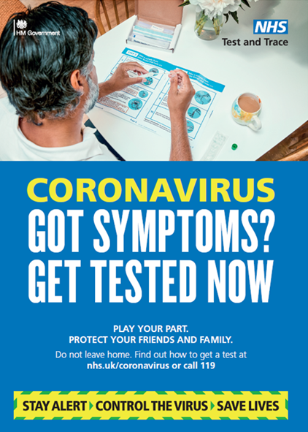
- Messaging (e.g. the posters shown below) should refer to specific symptoms of coronavirus, as knowledge of symptoms is low.
- Messages that highlight the effectiveness, accuracy and reliability of contact tracing services are likely to increase engagement with them.
- Messages about contact tracing services should state that data will be kept confidential and secure, and should outline what will happen to people’s data.
- Targeted messages encouraging those who are symptomatic to request a test may be warranted for those living in more deprived areas, and in certain geographical regions.
- Messages should emphasise the ease of access to tests and that the tests are free.
Figure 1: The journey through test, trace and isolate, showing frequencies and factors associated with uptake of behaviours.
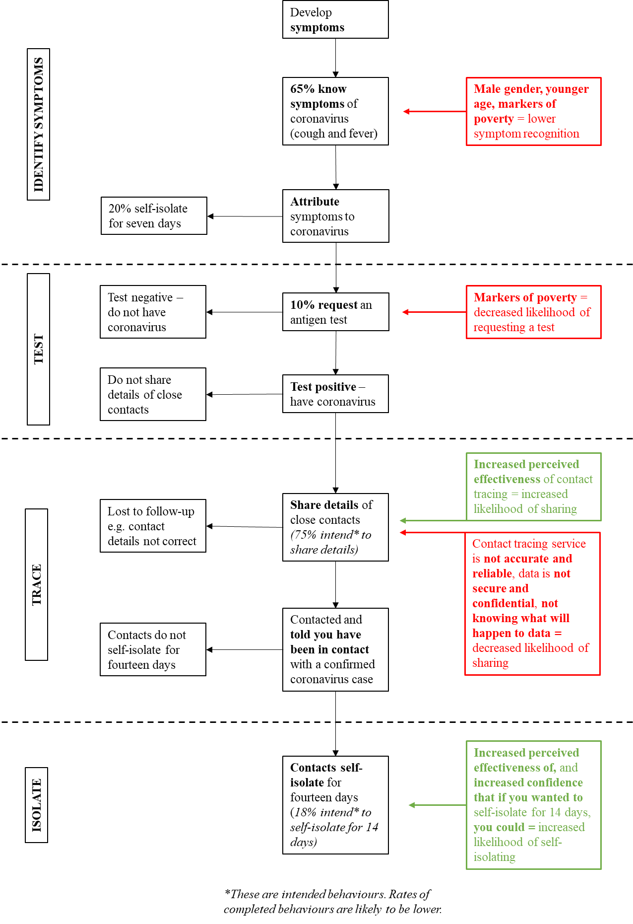

Knowledge of the symptoms of coronavirus
We investigated whether participants knew key symptoms of coronavirus (cough and high temperature / fever). We merged data from 30 March to 3 June to give larger sample sizes.
- Questions about the symptoms of coronavirus have been asked since 2 March. On average, 65% of people identified cough and high temperature / fever as symptoms of coronavirus. This has slightly decreased over time (Figure 2. Highest level of recognition: 71% in data collected on 6 to 8 April).
- Loss or change to sense of smell or taste was added as a symptom of coronavirus on 18 May. Using data from 25 May to 3 June, 25% of people identify cough, high temperature / fever, loss of sense of smell, and loss of sense of taste as symptoms of coronavirus.
- Not identifying cough and high temperature / fever as symptoms of coronavirus was associated with being male, younger, having a dependent child in the household, having a medical condition that makes you more susceptible to complications from coronavirus, living in a more deprived area, black and minority ethnicity, living alone and lower socio-economic grade (Table 1).
- Not identifying cough and high temperature / fever was also associated with increased worry, increased perceived risk of coronavirus to oneself, decreased perceived credibility of the Government, and decreased knowledge about Government guidance if you become symptomatic (Table 1).

Figure 2. Proportion of people who identify cough and high temperature / fever as symptoms of coronavirus.
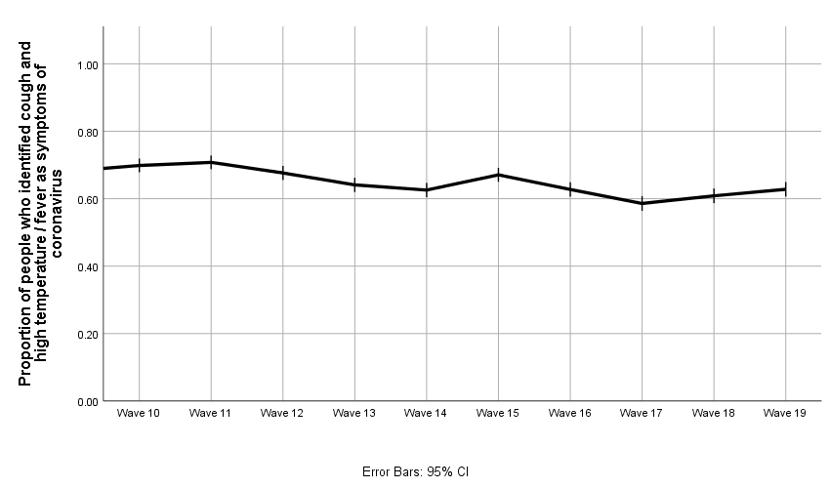
Table 1. Identification of symptoms of coronavirus. Associations with identifying cough and high temperature / fever as symptoms of coronavirus.
 | Identified cough and high temperature / fever as symptoms of coronavirus (n=12,717/19,652)
Small effect – more likely to identify symptoms | Having a smartphone (NB – introduced on 25 May), increased self-reported connectedness with others (NB –introduced on 6 April), thinking you have enough information about the symptoms of coronavirus (NB – introduced on 18 May).
Not associated | Having a household member with a chronic illness, working, education, marital status.
Small effect – less likely to identify symptoms | Later survey wave, region (those in London, the North West, Wales, the West Midlands, and Yorkshire and the Humber less likely than those in the East Midlands to identify symptoms), male gender, younger age, presence of a dependent child in the household, having a medical condition that makes you more susceptible to complications from coronavirus, living in a more deprived area, black or minority ethnicity, living alone, being self-employed, lower socio-economic grade, being a key worker, not speaking English as your first language (NB – introduced on 14 April), mental distress (NB –introduced on 20 April), increased worry about coronavirus, increased perceived risk of coronavirus to oneself, increased self-reported markers of poverty (NB –introduced on 6 April), increased total number of outings in past week, decreased perceived credibility of the Government.
Medium/large effect – less likely to identify symptoms | Decreased knowledge about Government guidance if you become symptomatic.

Requesting a test
We investigated whether participants who had experienced symptoms of coronavirus (cough, high temperature / fever, loss of sense of smell, or loss of sense of taste) in the last seven days requested an antigen test. We merged data from 25 May to 3 June to give larger sample sizes.
- Of those who were symptomatic, 10% reported that they had requested a test.
- In those who were not symptomatic, intention to request a test if they developed symptoms, was higher (35%).
- 57% of people reported that they had enough information from the Government and other authorities about testing, including who is eligible and how to get tested (Table 2). Note that this is perceived information sufficiency, not an objective measure of knowledge about who is eligible to be tested or how to request a test.
- 83% of people agreed or strongly agreed that an effective way to prevent the spread of coronavirus was to test people with symptoms (Table 2).
- 62% of people agreed or strongly agreed that they could book a test (Table 2).
- 58% of people agreed or strongly agreed that they could go to a drive-through centre to get tested and 59% agreed or strongly agreed that they could get a home-testing kit (Table 2).
- Approximately two thirds of people agreed or strongly agreed that they could return a home-testing kit by post (65%) or via a courier (66%) (Table 2).
- We investigated factors associated with reporting that you had requested a test. Results of these analyses should be treated with caution due to the small number of people who reported that they had requested a test.
- Decreased likelihood of reporting that you had requested a test when symptomatic was associated with: living in London or the West Midlands (compared to the East Midlands), living in a more deprived area, and greater self-reported poverty (Table 3).
- Increased likelihood of reporting that you had requested a test when symptomatic was associated with being married or partnered (Table 3).

Table 2. Percentage of people who report that they have enough information from the Government and other authorities about testing, contact tracing services, and self-isolation.
To what extent do you agree or disagree that you have enough information from the Government and other public authorities with regards to the following areas? | Strongly agree (%) | Agree (%) | Neither (%) | Disagree (%) | Strongly disagree (%) | Don’t know (%)
Testing (including who is eligible and how to get tested) (included 1 to 3 June, n=2003) | 18 | 39 | 21 | 16 | 5 | 1
Contact tracing programmes (such as NHS Test and Trace) (included 1 to 3 June, n=2003) | 15 | 37 | 24 | 17 | 7 | 1
Self-isolation (included 18 May to 3 June, n=6007) | 32 | 52 | 11 | 3 | 1 | 1
An effective way to prevent the spread of coronavirus is to… | Strongly agree (%) | Agree (%) | Neither (%) | Disagree (%) | Strongly disagree (%) | Don’t know (%)
Test people with symptoms to confirm whether they have coronavirus (included 25 May to 3 June, n=4004) | 46 | 36 | 12 | 2 | 1 | 2
Have a contact tracing programme which anonymously notifies people who have come into close contact with a confirmed coronavirus case to self-isolate (included 1 to 3 June, n=2003) | 28 | 37 | 23 | 5 | 4 | 4
How confident are you that, if you wanted to, you could… | Strongly agree (%) | Agree (%) | Neither (%) | Disagree (%) | Strongly disagree (%) | Don’t know (%)
Book a test online or via telephone to confirm whether you have coronavirus (included 25 May to 3 June, n=4004) | 28 | 34 | 22 | 8 | 3 | 5
Go to a drive-through centre to get tested for coronavirus included 25 May to 3 June, n=4004) | 26 | 32 | 19 | 11 | 7 | 5
Get a home-testing kit for coronavirus delivered to your home (included 25 May to 3 June, n=4004) | 27 | 32 | 22 | 9 | 4 | 5
Return a completed home-testing kit for coronavirus via post (included 25 to 27 May, n=2001) | 33 | 33 | 20 | 6 | 3 | 5
Return a completed home-testing kit for coronavirus via courier (e.g. UPS, Hermes) (included 1 to 3 June, n=2003) | 30 | 35 | 21 | 6 | 3 | 5
Where percentages do not add to 100%, this is due to rounding error.

Table 3. Testing, self-reported behaviour. Associations with reporting that you requested a test in those who had symptoms of coronavirus (analysing data from 25 May to 3 June). These results should be taken with caution due to the small sample size, and small number of people who reported that they had requested a test.
 | Reported requesting an antigen test if symptomatic oneself (n=33/321)
Medium/large effect – more likely to have requested a test | Being married/partnered.
Not associated | Survey wave, gender, age, presence of a dependent child in the household, having a medical condition that makes you more susceptible to complications from coronavirus, having a household member with a chronic illness, working, ethnicity, education, living alone, being self-employed, socio-economic grade, being a key worker, speaking English as your first language, having a smartphone, mental distress, identifying cough and high temperature as symptoms of coronavirus, worry about coronavirus, perceived risk of coronavirus to oneself, self-reported connectedness with others, total number of outings in past week, knowledge about Government guidance if you become symptomatic, thinking you have enough knowledge about testing, perceived effectiveness of testing, confidence that if you wanted to you could book an antigen test, confidence that if you wanted to you could go to a drive-through testing centre, confidence that if you wanted to you could get a home-testing kit delivered, confidence that if you wanted to you could return a home-testing kit by post (NB – only asked on 25 to 27 May), confidence that if you wanted to you could return a home-testing kit by courier (NB – only asked on 1 to 3 June), credibility of the Government.
Small effect – less likely to have requested a test | Increased self-reported markers of poverty.
Medium/large effect – less likely to have requested a test | Region (those in London and West Midlands less likely than those in the East Midlands to request a test), living in a more deprived area (2nd and 3rd quartiles less likely than first quartile).

Engaging with contact tracers
We investigated whether participants intended to share details of their close contacts if they had tested positive for coronavirus. We used data from 1 to 3 June.
- 75% of people reported that they would “probably” or “definitely” share details of their close contacts if they had tested positive for coronavirus and had been asked by the NHS contact tracing service to share details (17% not sure, 8% probably or definitely would not). This is intended behaviour; actual behaviour will be lower.
- 52% of people reported that they had enough information from the Government and other authorities about contract tracing services, including who is eligible and how to get tested (Table 2). Note that this is perceived information sufficiency, not a measure of knowledge about contact tracing services.
- 65% of people agreed or strongly agreed that an effective way to prevent the spread of coronavirus would be to have a contact tracing service in place (Table 2).
- Demographic factors predicted 2% of the variance. This is a very small amount. Increasing age and female gender were associated with increased intention to pass on details of close contacts (Table 4).
- Increased perceived effectiveness of contact tracing services and demographic factors predicted 15% of the variance (this is a reasonable amount), with people who thought that an effective way to slow the spread of coronavirus was to have a contact tracing service being more likely to intend to pass on details of their close contacts (Table 4).
- Not thinking that the contact tracing service was accurate and reliable and demographic factors predicted 15% of the variance, with people who thought that the contact tracing service was not accurate and reliable being less likely to intend to pass on contact details of their close contacts (Table 4). Not knowing if data would be secure and confidential, and not knowing what would happen to the data and demographic factors also predicted a reasonable amount of the variance.
- Self-reported reasons that would stop someone passing on details of their close contacts to the NHS were: don’t know if the data will be secure and confidential (22%); don’t know what will happen to the data (20%); don’t think the contact tracing system is accurate and reliable (15%); it would cause stress (9%); it would cause inconvenience (8%); don’t want to be responsible for others being told to self-isolate (7%); my contacts would be angry (6%); it would cause loss of income (5%); and, worry about being found out by contacts (5%).

Table 4. Tracking, intended behaviour. Factors associated with intention to supply NHS contact tracing service with details of close contacts if tested positive for coronavirus (1 to 3 June).
 | Intention to supply contact details (n=1858)
Associated with increased intention | Female gender, older age, being a key worker, having a smartphone, identifying cough and high temperature as symptoms of coronavirus, increased worry about coronavirus, increased perceived risk of coronavirus to oneself, increased self-reported connectedness with others, feeling that you have enough information about the contact tracing service, increased perceived effectiveness of contact tracing service reason not to pass on contact details – no reason selected, would pass contact details on, increased credibility of the Government.
No association | Region, presence of dependent child in household, having a medical condition that makes you more susceptible to complications from coronavirus, having a household member with a chronic illness, working, index of multiple deprivation, ethnicity, education, living alone, marital status, being self-employed, speaking English as your first language, total number of outings in last seven days, reason not to pass on contact details – it would cause loss of income to my contacts, reason not to pass on contact details – worry about being found out by contacts.
Associated with decreased intention | Lower socioeconomic grade (highest earner is manual worker), mental distress, increased self-reported markers of poverty, reason not to pass on contact details – it would cause inconvenience to my contacts, reason not to pass on contact details – it would cause stress to my contacts, reason not to pass on contact details – my contacts would be angry, reason not to pass on contact details – don’t think contact tracing service is accurate and reliable, reason not to pass on contact details – don’t know what will happen to the data, reason not to pass on contact details – don’t know if the data will be secure and confidential, reason not to pass on contact details – don’t want to be responsible for others having to self-isolate.

Adhering to isolation if symptomatic
We investigated whether participants who had experienced symptoms of coronavirus in the last week were staying at home for 7 or 14 days. We merged data from 30 March to 3 June to give larger sample sizes.
- 36% of people who had symptoms of coronavirus reported staying at home for 7 or 14 days. Symptoms were having high temperature/fever or cough; loss of sense of smell and loss of sense of taste were added on 25 May. This percentage is decreasing over time, and was 20% on 1 to 3 June (Figure 3).
- In those who were not symptomatic, intention to stay at home for 7 or 14 days if you developed symptoms was much higher (81%).
- 84% of people reported that they had enough information from the Government and other authorities about self-isolation (Table 2). This is a measure of perceived information sufficiency, not of objective knowledge.
- Reporting that you were staying at home for seven/fourteen days if symptomatic was associated with: identifying cough and high temperature / fever as symptoms of coronavirus, increased perceived effectiveness of self-isolation for seven days if you become symptomatic, increased confidence that if you wanted to you could stay at home for seven days, higher socioeconomic grade, and better knowledge of Government guidelines (Table 5). There were also some age effects, with those aged 25 to 44 years being less likely to stay at home than those aged 16 to 24 years.
- Self-reported reasons why people had left their home since they developed symptoms were: to go to the shops for groceries/pharmacy (20%); symptoms got better (17%); for a medical need other than coronavirus (16%); to go to the shops, for things other than groceries/pharmacy (15%); symptoms were only mild (15%); to help or provide care for a vulnerable person (14%); to go for a walk or some other exercise (14%); don’t think it is necessary to stay at home (12%); to go out to work (11%); symptoms got worse (11%); and, to meet up with friends and/or family (10%).
Figure 3. Proportion of people intending to stay at home for 7 or 14 days if they develop symptoms (red line) and who reported staying at home for 7 or 14 days when they developed symptoms (blue line).
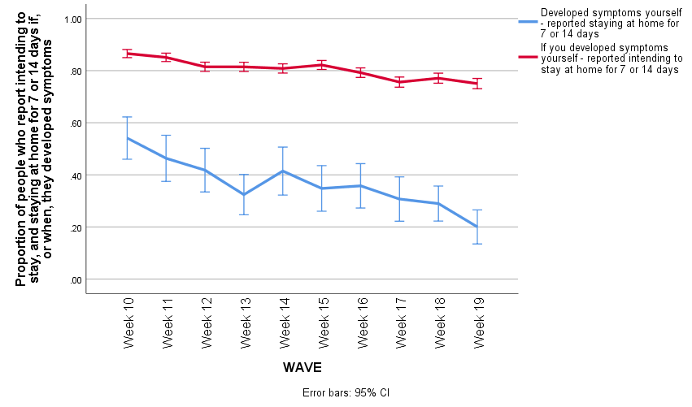

Adhering to isolation if a household member is symptomatic
We investigated whether participants who had a household member who had experienced symptoms of coronavirus in the last week, but who had not experienced symptoms themselves, were staying at home for 7 or 14 days. We merged data from 30 March to 3 June to give larger sample sizes.
- 43% of people who reported that a household member, but not they themselves, had symptoms of coronavirus reported staying at home for 7 or 14 days. This has decreased over time, and was 30% on 1 to 3 June (Figure 4).
- Intention to stay at home for 7 or 14 days if a household member developed symptoms of coronavirus was much higher (75%).
- Reporting that you were staying at home for seven/fourteen days if a household member, but not you yourself, were symptomatic was associated with: increased perceived effectiveness of self-isolation for fourteen days if you become symptomatic, increased confidence that if you wanted to you could stay at home for fourteen days, and better knowledge of Government guidelines (Table 5).
- Self-reported reasons why people had left their home since a household member (but not they themselves) developed symptoms were: household member’s symptoms got better (26%); household member’s symptoms were only mild (17%); household member’s symptoms got worse (16%); to go to the shops, for groceries/pharmacy (15%); for a medical need (other than coronavirus; 15%); household member’s symptoms did not persist (12%); to go for a walk or some other exercise (9%); to go to the shops, for things other than groceries/pharmacy (8%); to go out to work (7%); to help or provide care for a vulnerable person (6%); don’t think it is necessary to stay at home (2%); and to meet up with friends and/or family (2%).

Figure 4. Proportion of people intending to stay at home for 7 or 14 days if a household member were to develop symptoms (red line) and who reported staying at home for 7 or 14 days when a household member developed symptoms (blue line). The numbers included in each wave are very small, ranging from 25 to 79, and so the results should be treated with caution.

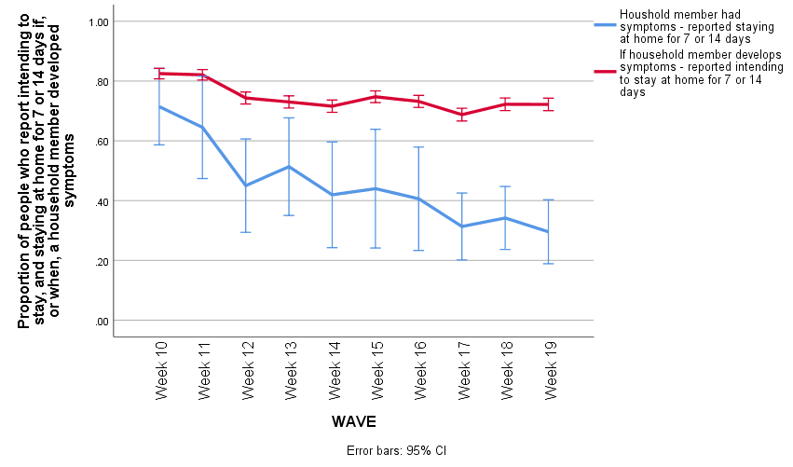

Table 5. Isolating, self-reported behaviour. Associations with staying at home if you, or a household member, had experienced symptoms of coronavirus in the last seven days (analysing data from 30 March to 3 June together).
 | Reported staying at home for 7/14 days if symptomatic oneself (n=483/1329) | Reported staying at home for 7/14 days if a household member, but not you yourself, had symptoms (n=198/462)
Small effect – more likely to stay at home | Identifying cough and high temperature as symptoms of coronavirus, increased perceived effectiveness of staying at home for 7 days if symptomatic (NB – removed on 25 May), increased confidence that if you wanted to you could stay at home for 7 days (NB – introduced on 14 April). | Increased perceived effectiveness of staying at home for 14 days if someone in your household becomes symptomatic, increased confidence that if you wanted to your whole household could stay at home for 14 days (NB – introduced on 14 April).
Not associated | Region, gender, presence of dependent children in the household, having a medical condition that makes you more susceptible to complications from coronavirus, having a household member with a chronic illness, working, index of multiple deprivation, ethnicity, education, living alone, marital status, being self-employed, being a key worker, speaking English as your first language (NB – introduced on 14 April), having a smartphone (NB – introduced on 25 May), mental distress (NB –introduced on 20 April), worry about coronavirus, perceived risk of coronavirus to oneself, self-reported connectedness to others (NB –introduced on 6 April), self-reported markers of poverty (NB –introduced on 6 April), total number of outings made in last week, credibility of the Government. | Region, gender, age, presence of dependent children in the household, having a medical condition that makes you more susceptible to complications from coronavirus, having a household member with a chronic illness, working, index of multiple deprivation, ethnicity, education, living alone, marital status, being self-employed, socioeconomic grade, being a key worker, speaking English as your first language (NB – introduced on 14 April), having a smartphone (NB – introduced on 25 May), mental distress (NB –introduced on 20 April), knowing that cough and high temperature are symptoms of coronavirus, worry about coronavirus, perceived risk of coronavirus to oneself, self-reported connectedness to others (NB –introduced on 6 April), self-reported markers of poverty (NB –introduced on 6 April), total number of outings made in last week, credibility of the Government.
Small effect – less likely to stay at home | Later survey wave, being aged 25 to 44 years (vs 18-24 years), lower socioeconomic grade (highest earner is manual worker), not knowing/being unsure about Government guidance if you become symptomatic. | Later survey wave.
Medium effect – less likely to stay at home |  | Not knowing/being unsure about Government guidance if a household member become symptomatic.

Adhering to isolation if contacted by a contact tracer
We investigated whether participants who had been contacted by a contact tracer had self-isolated. We used data from 1 to 3 June. Due to small sample sizes, we were unable to run analyses of associations.
- 4% of people reported that they have already been contacted by a contact tracing service (n=72/2003, asked 1 to 3 June only). Of contacts of coronavirus cases, 39% (n=28) reported that they self-isolated for 14 days or longer. These numbers are very small and should be taken with caution. 31% (n=22) did not select that they self-isolated (not leaving home at all) for any length of time.
- Those who reported that they had not been contacted by a contact tracing service, or who did not know if they had been contacted were asked follow-up questions about their intended actions if they were contacted by a contact tracing service (n=1931). Of these people, 18% (n=348) reported that they would self-isolate for 14 days or longer. This is intended behaviour; actual behaviour is likely to be lower. 12% (n=229) did not select that they would self-isolate (not leaving home at all) for any length of time.

Datasets used:
- Department of Health and Social Care weekly tracker from 30 March to 3 June 2020.
  - Tracking DHSC marketing, coronavirus attitudes, beliefs, knowledge, reported behaviour, satisfaction with Government response, credibility of Government.
  - Across these weekly waves, we also recoded knowledge about Government guidance if you or a household member had symptoms of coronavirus.
  - We computed a variable indicating if people understood the guidance for if they or someone in their household developed symptoms. For these variables, we coded someone as being incorrect/unsure if they answered “true” or “don’t know” to being able to go out if [your] symptoms were mild, to go shopping for groceries/pharmacy, to go shopping for things other than groceries/pharmacy, to help/provide care, or to meet up with friends. Participants were coded as being correct if they answered “false” to all of these statements.
    - Across waves 10-19, 60.7% people (n=12,171/20,057) knew that if you developed symptoms of coronavirus, you should not go out if your symptoms were mild, to go shopping for groceries/pharmacy, to go shopping for items other than groceries/pharmacy, to go for a walk or some other exercise, or to help/provide care for someone else.
    - Across waves 10-19, 61.4% people (n=12,308/20,057) knew that if your household member developed symptoms of coronavirus, you should not go out if your symptoms were mild, to go shopping for groceries/pharmacy, to go shopping for items other than groceries/pharmacy, to go for a walk or some other exercise, or to help/provide care for someone else.
  - The self-reported connectedness variable combines: “I keep in touch with family and friends who I don't live with”, “There is enough space in my home for everyone currently living in my household”, “I feel connected to family/friends”, and “I have someone to talk to about my worries”.
  - The self-reported poverty variable combines “I am struggling to make ends meet”, “I am skipping meals I would usually have”, and “I am finding my current living situation difficult”.
  - We investigated factors associated with identifying cough and high temperature / fever using adjusted logistic regressions. For these analyses we merged data from 30 March to 3 June.
  - We investigated factors associated with requesting an antigen test for coronavirus using adjusted logistic regressions. For these analyses we merged data from 25 May to 3 June.
  - We investigated factors associated with intention to share details of your close contacts with a contact tracing service using adjusted linear regressions. For these analyses we used data from 1 to 3 June.
  - We investigated factors associated with reporting that you were staying at home for seven or fourteen days, if you or a household member (but not you yourself) had experienced symptoms of coronavirus in the last seven days using adjusted logistic regressions. For these analyses we merged data from 30 March to 3 June.
  - In all analyses, we controlled for survey wave, region, gender, age, presence of a dependent child, being clinically extremely vulnerable to coronavirus oneself, having a household member with a chronic illness, working, index of multiple deprivation, ethnicity, education, and living alone.
  - For logistic regression analyses, a small effect was defined as an aOR of less than 1.68 / 0.60.
  - For linear regression analyses, we used amount of the variance explained as an indicator of the strength of the association.
  - Data collected weekly (Monday to Wednesday) since late January 2020. For this report, we used data from week 10 onwards.
  - N~2000 per wave.
  - Market research company commissioned: BMG Research.

Data collection dates:
Wave 10 | 30 March - 1 April
Wave 11 | 6 - 8 April
Wave 12 | 14 - 15 April
Wave 13 | 20 - 22 April
Wave 14 | 27 - 29 April
Wave 15 | 4 - 6 May
Wave 16 | 11 - 13 May
Wave 17 | 18 – 20 May
Wave 18 | 25 – 27 May
Wave 19 | 1 – 3 June

Please note that this work has been conducted rapidly, and has not been peer reviewed or subject to normal quality control measures.

Dr Louise E. Smith (KCL), Professor Nicola T. Fear (KCL), Dr Henry W.W. Potts (UCL), Professor Susan Michie (UCL), Professor Richard Amlȏt (PHE), Dr G James Rubin (KCL)

Contact details: louise.e.smith@kcl.ac.uk, richard.amlot@phe.gov.uk, gideon.rubin@kcl.ac.uk

